Tasks on Jenkins - 03

Single Box Environment – Jenkins, SonarQube, Maven, Nexus All in one instance. Used for development not recommended for Production.
Multi-Box Environment - Jenkins, SonarQube, Maven, Nexus All in different Ec2 instances. Used for Production.

We have 6 stages in CICD (Continuous Integration and Continuous Deployment/Delivery):
1) Git Clone – To clone the source code.
2) SonarQube Integration – To check the Quality of the code.
3) Maven Compilation – To create/Compile the source code & create package for us.
4) Nexus Artifactory – To store our Application in Nexus Repository.
5) Post Build Actions – To sent alert with build output to the user.
6) Deploy to Tomcat/Kubernetes – Deployment to tomcat webapps.

1-5 comes under CI & 6 in CD.

6) Deploy to Tomcat/Kubernetes.
Deployment Stages:
1) Deploy to Tomcat.
2) Deploy to EC2.
3) Deploy to Kubernetes.

Quality Gate
What it is:
A pass/fail check based on defined code quality conditions (like bugs, coverage, duplications).
Why it's important (real-time use):
- Used in CI/CD pipelines to stop deployment if code is bad.
- Example: "Coverage < 80%" → FAIL the build
Interview Tip:
“A Quality Gate helps enforce coding standards automatically during builds. I use it in Jenkins pipelines to block bad code from reaching production.”

Quality Profile
What it is:
A set of rules for each programming language used during code analysis.
Why it's important (real-time use):
- You can customize rules (e.g., ignore console.log in JS).
- Teams use different profiles for Java, JavaScript, etc.
Interview Tip:
“We used customized Quality Profiles per project — especially in microservices where different teams use different stacks.”

Dashboard
What it is:
The main SonarQube UI view showing project metrics, issues, code smells, etc.
Why it's important (real-time use):
- Shows code health trends, new issues, and who broke the code.
- Developers and managers both refer to this to track quality over time.
Interview Tip:
“I use the dashboard daily to check if new commits introduced bugs or if coverage dropped. It helps in team stand-ups and quality audits.”

1) Create one jenkins job using the below code and create three stages. stage1: Git clone to download the source code. stage2: Sonarqube Integration to check the quality of code stage3: Slack Integration to send the alerts to slack. URL: https://github.com/betawins/VProfile-1.git

Stage1: Git clone to download the source code.
Click New Item
→ Enter a name: VPrpfile-1
→ Select Freestyle project
→ Click OK
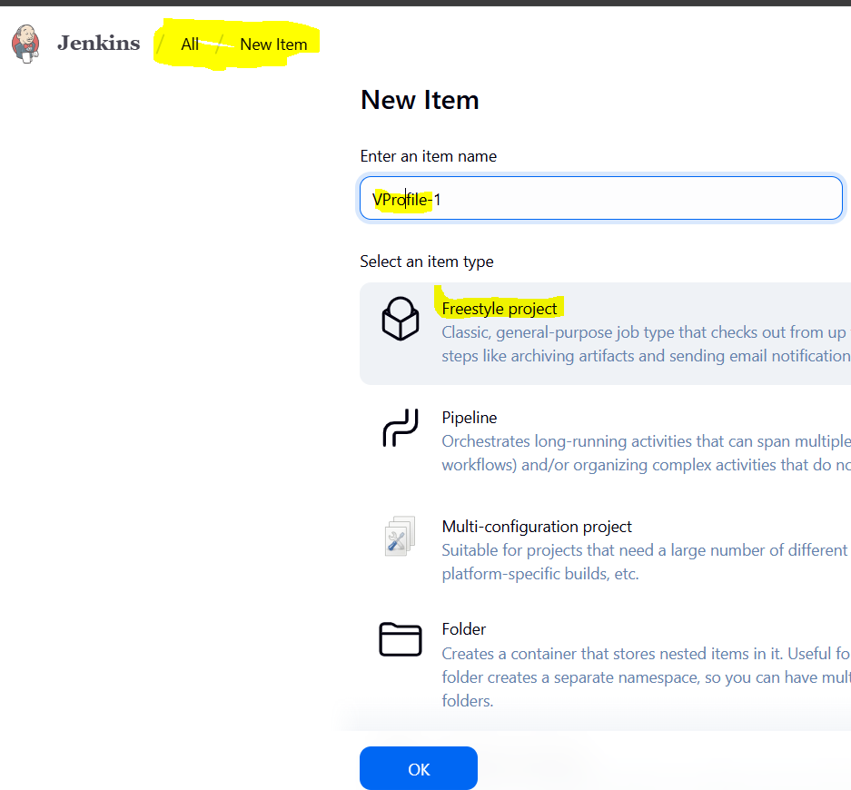
Scroll to Source Code Management
→ Select Git
→ In Repository URL, paste:
https://github.com/betawins/Vprofile-1.git
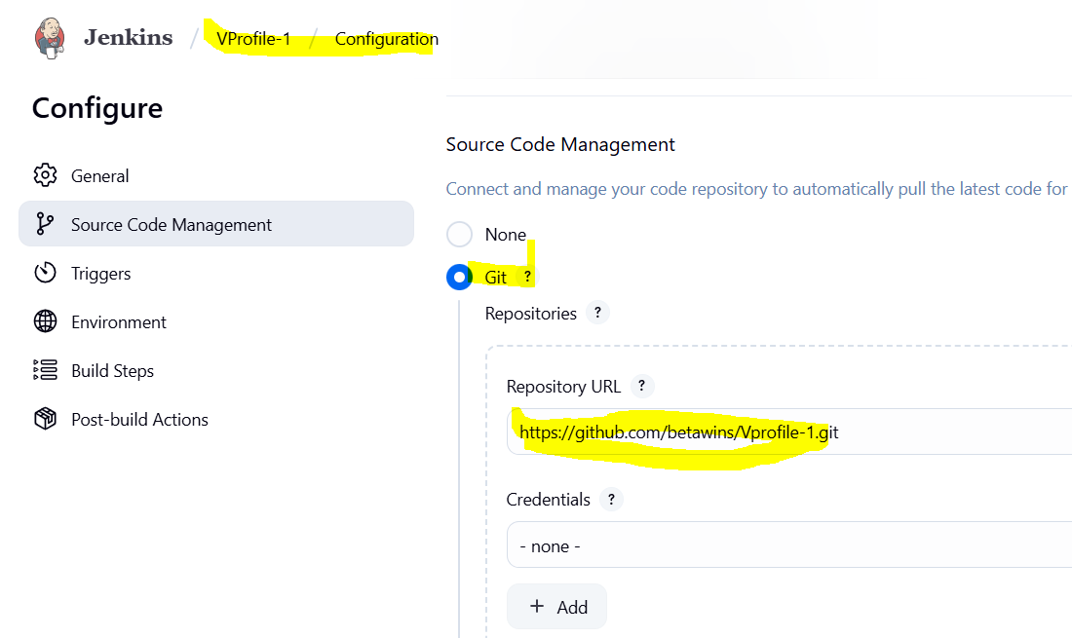

Click Save
→ Click Build Now
→ Click on the latest build → Console Output
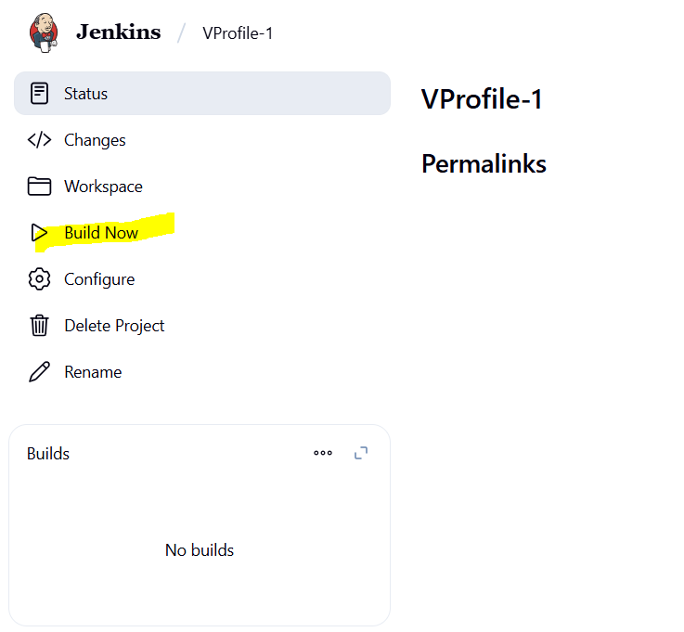

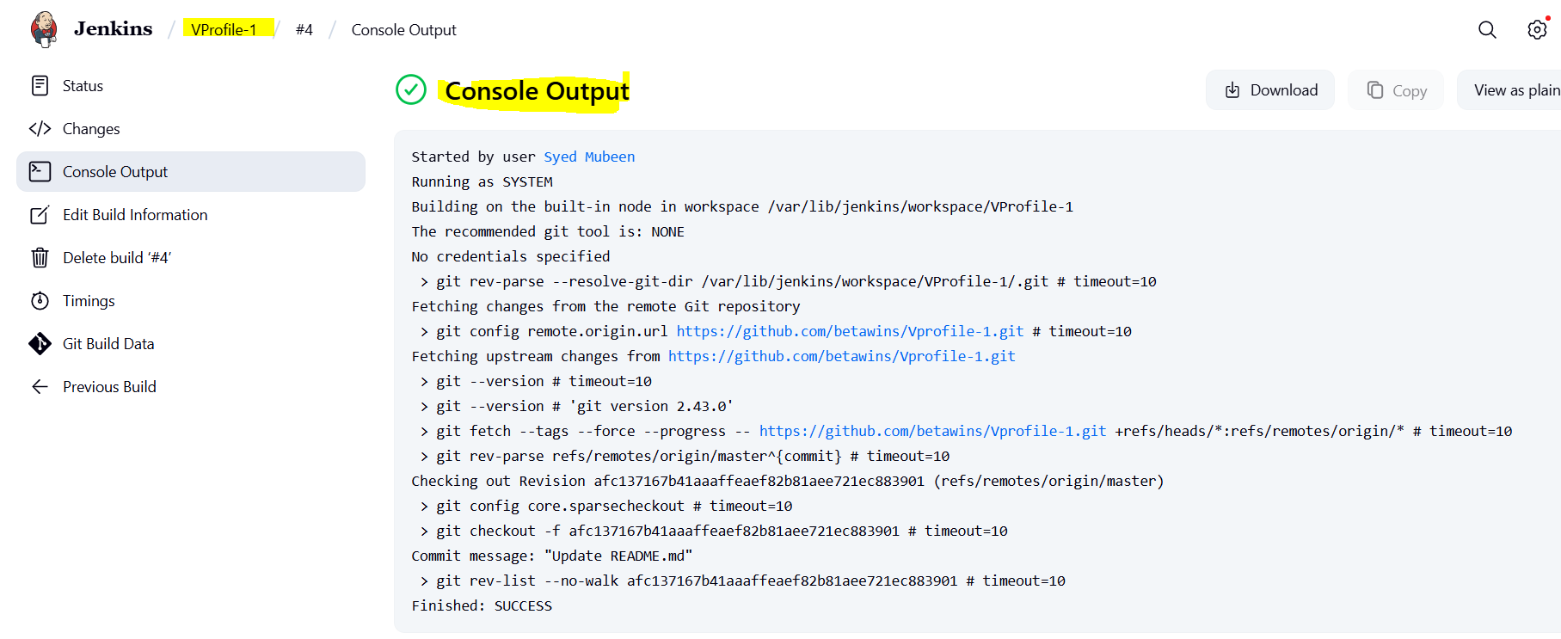

Verify in server at var/lib/Jenkins/workspace/VProfile-1 path.

Stage2: SonarQube Integration to check the quality of code

SonarQube Installation

SonarQube provides the capability to not only show health of an application but also to highlight issues newly introduced. With a Quality Gate in place, you can fix the leak and therefore improve code quality systematically.

Prerequisites
1. EC2 instance with Java installed
2. Use t2.large with atleast 20gb memory to run sonarqube.
3. PostgreSQL Database Server or MySQL RDS instance.

Installing EC2 instance with Ubuntu and Prerequisites:

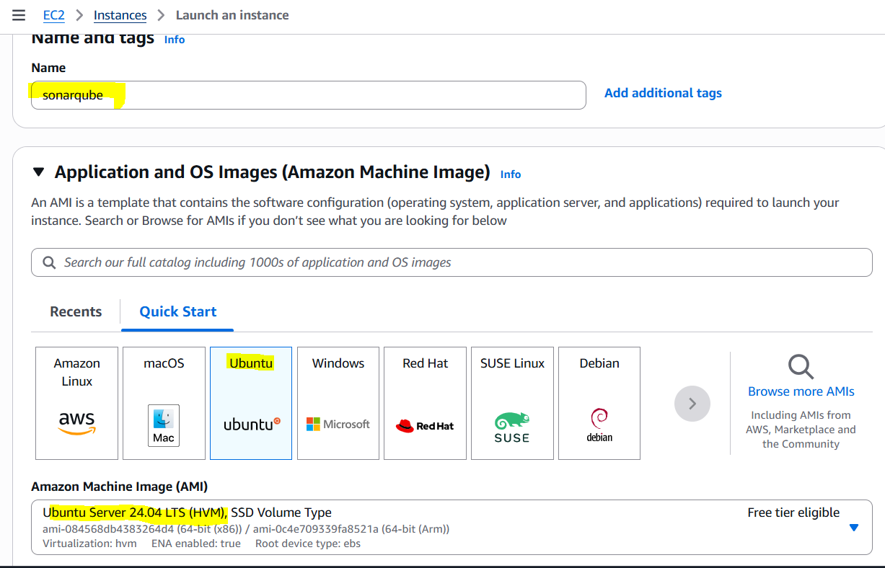
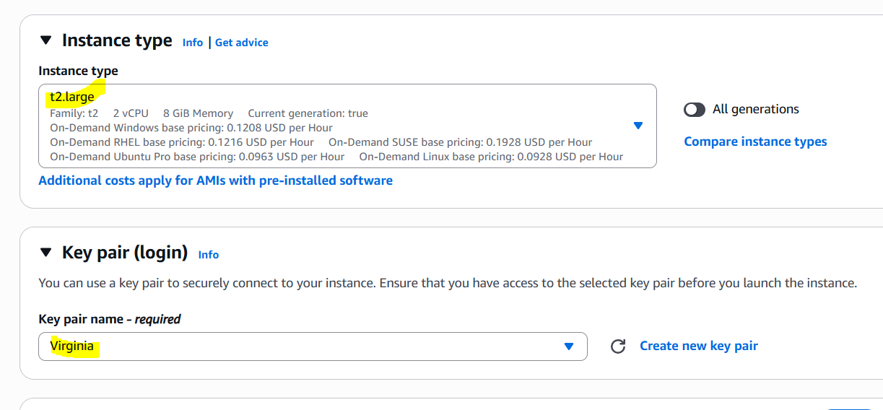
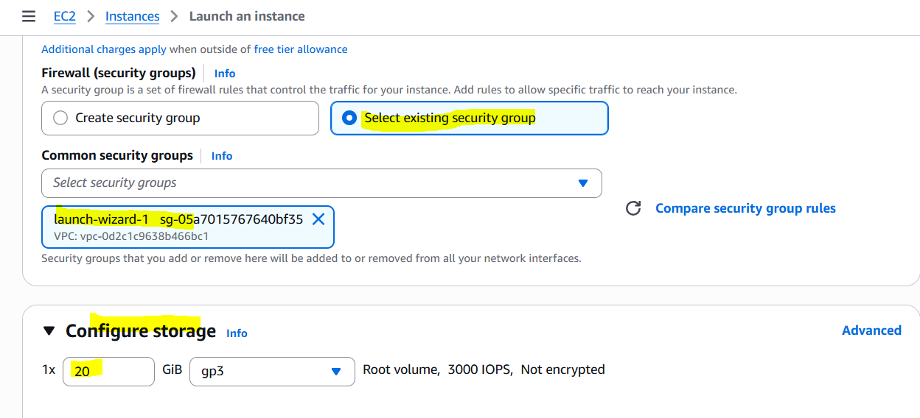
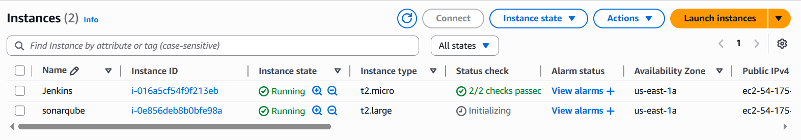

Installation:

Install java 17 version
sudo apt update
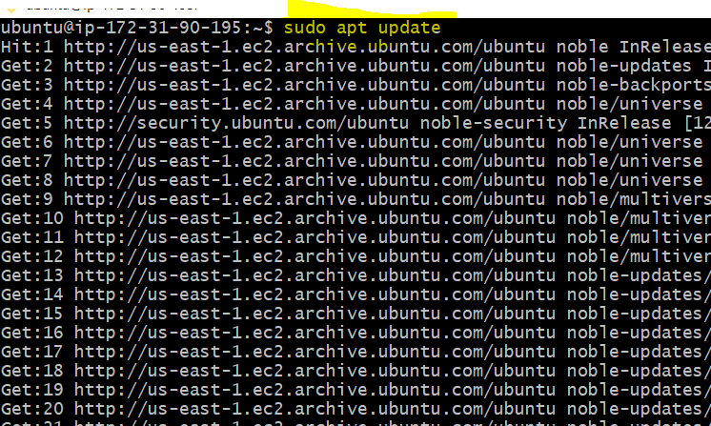
sudo apt install -y openjdk-17-jdk
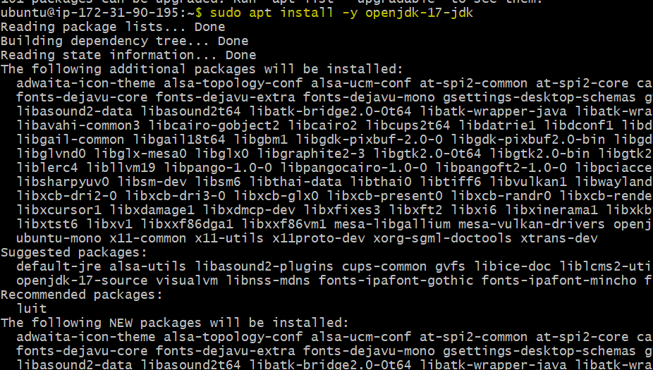

java --version
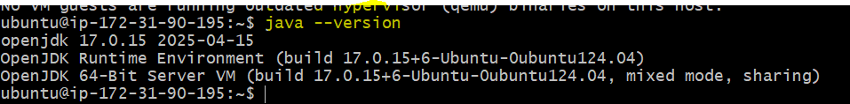

Install PostgreSQL
sudo apt install -y postgresql postgresql-contrib
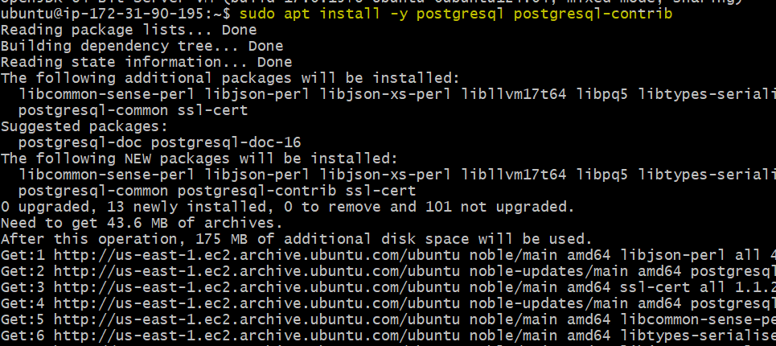

Start and enable PostgreSQL:
sudo systemctl enable postgresql
sudo systemctl start postgresql
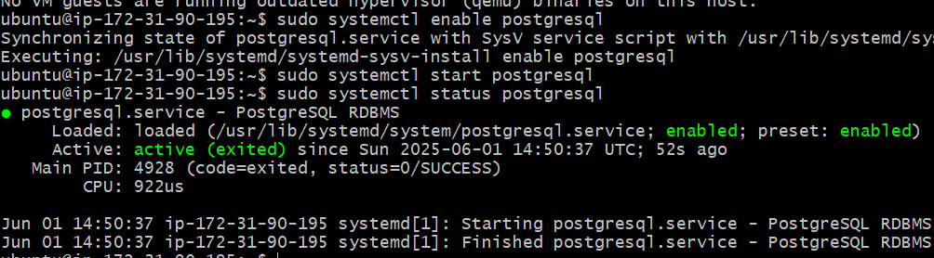
Switch to PostgreSQL user:
sudo -i -u postgres
Create SonarQube database and user:
psql
CREATE DATABASE sonar;
CREATE USER sonar WITH ENCRYPTED PASSWORD 'Sonar@123';
GRANT ALL PRIVILEGES ON DATABASE sonar TO sonar;
\q
exit
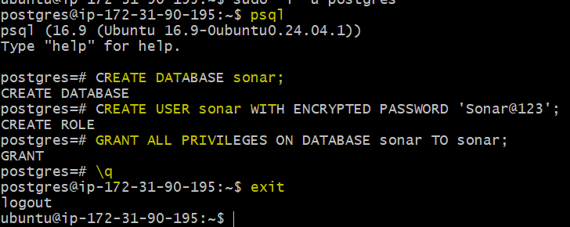

We connect to PostgreSQL as the superuser, switch to the SonarQube database, grant full privileges on the public schema and database to the SonarQube user, optionally make that user the schema owner or superuser, then exit.

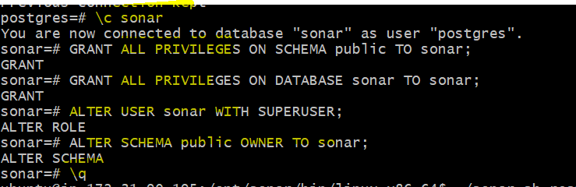

Restart the service.

Download stable SonarQube version from below website.

Website: https://www.sonarqube.org/downloads/

Note: This Article written for SonarQube 25.5.0.

Download & unzip SonarQube 2.5.5.0

cd /opt
sudo wget https://binaries.sonarsource.com/Distribution/sonarqube/sonarqube-25.5.0.107428.zip
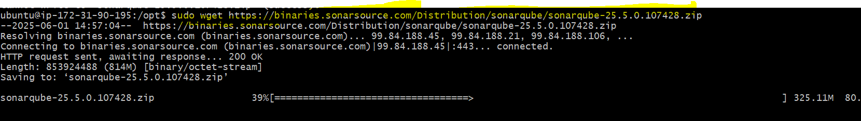
sudo unzip sonarqube-25.5.0.107428.zip
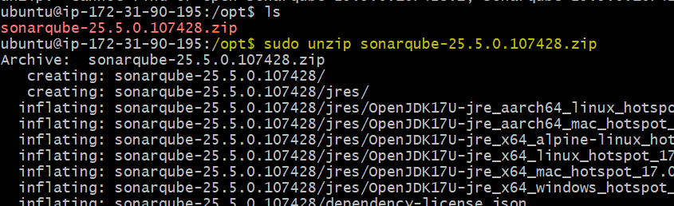

sudo mv sonarqube-25.5.0.107428 sonar
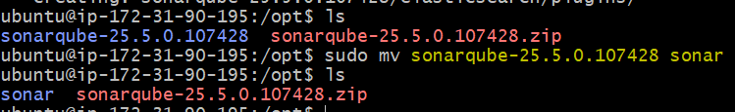

So far you have configured required database information on postgreSQL. Let’s Jump back to your EC2 instance and enable SonarQube properties file to connect his Database.

ON EC2 Instance
Edit sonar properties file to uncomment and provide required information for below properties.

File Name: /opt/sonar/conf/sonar.properties (uncomment/add)

sonar.jdbc.username=sonar
sonar.jdbc.password=Sonar@123
sonar.jdbc.url=jdbc:postgresql://localhost:5432/sonar

sonar.web.host=0.0.0.0
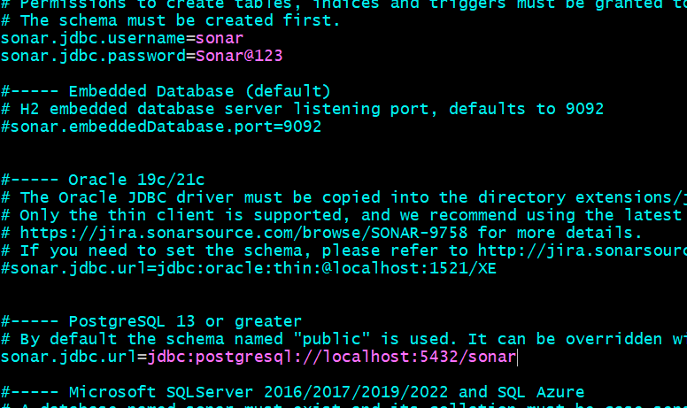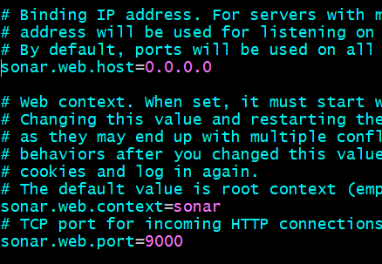

Give ubuntu ownership and permissions of SonarQube folder:
sudo chown -R ubuntu:ubuntu /opt/sonar
sudo chmod -R 755 /opt/sonar
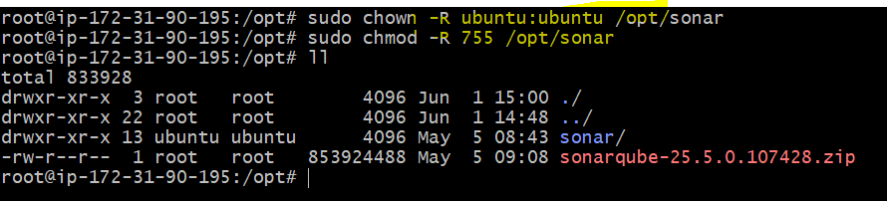

Switch to ubuntu user:
su – ubuntu
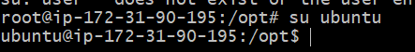

Start SonarQube service

cd /opt/sonar/bin/linux-x86-64/
./sonar.sh start
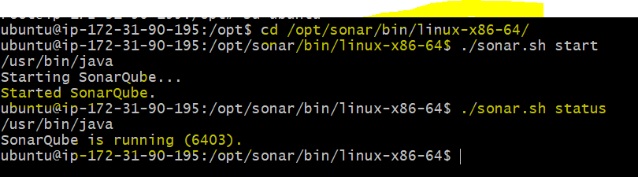

SonarQube application uses port 9000. access SonarQube from browser

http://<EC2_PUBLIC_IP>:9000/sonar

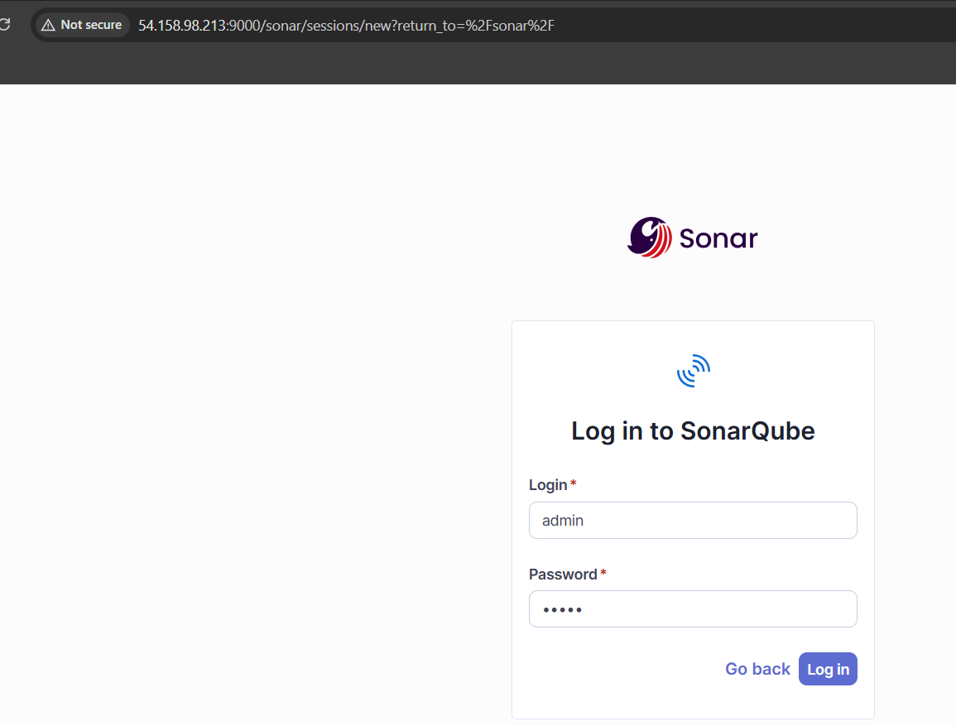

Default credentials for sonarqube.
Username : admin
Password: admin

Mubsad321123.

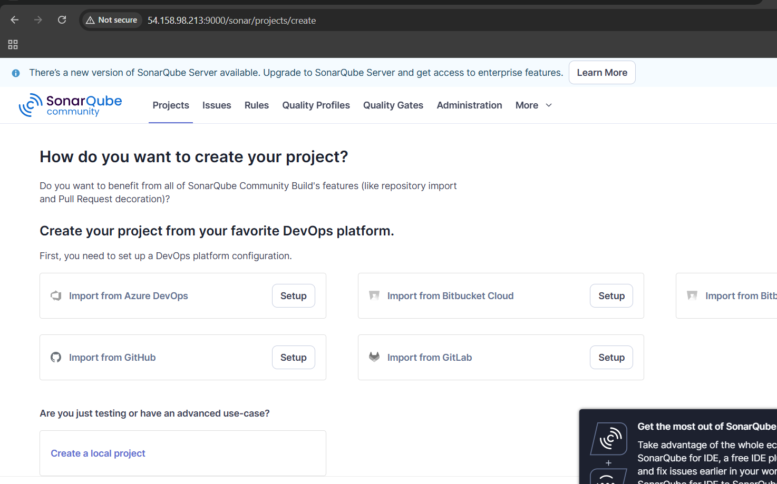

NOTES
Check whether you enabled port 9000 in EC2 instance security group

Important Points:
PostgreSQL port number: 5432

sonarqube port: 9000

sonarqube logs : /opt/sonar/logs

We can find four different logs:
a) access.log
b) es.log aka elastic search
c) sonar.log
d) web.log

Install Sonar Scanner on Jenkins Server
Switch to root user on Jenkins EC2
sudo su -
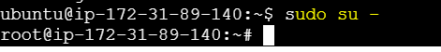

Download and install Sonar Scanner
cd /opt
wget https://binaries.sonarsource.com/Distribution/sonar-scanner-cli/sonar-scanner-cli-5.0.1.3006-linux.zip
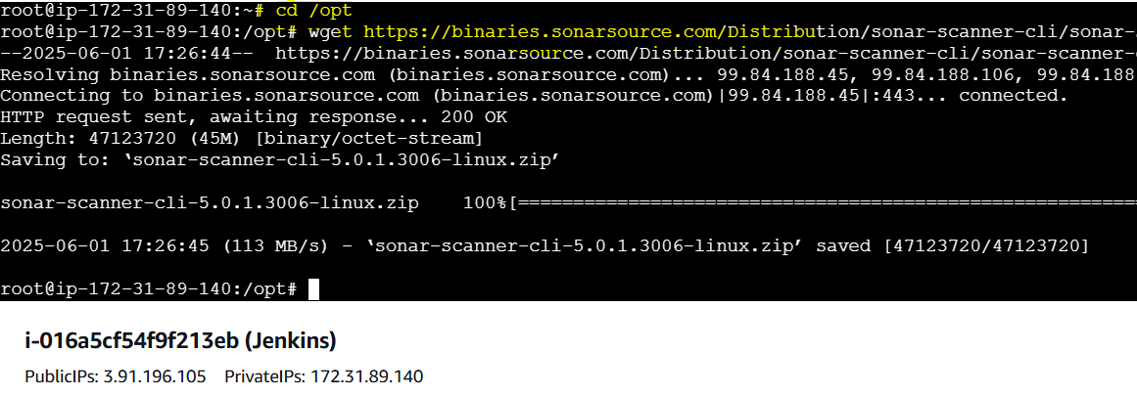

unzip sonar-scanner-cli-5.0.1.3006-linux.zip
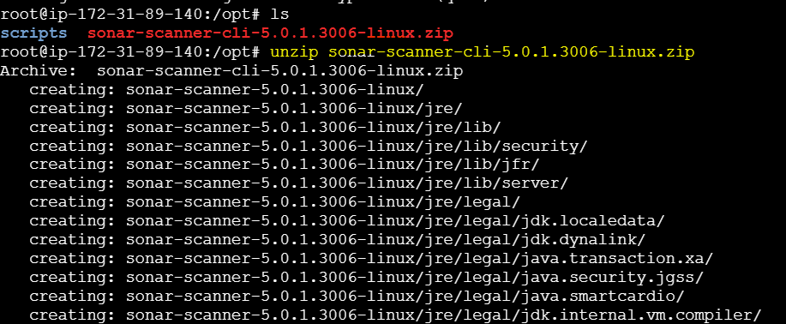

mv sonar-scanner-* sonar-scanner
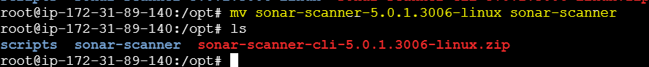

Configure Sonar Scanner Properties
Edit the Sonar Scanner configuration
vi /opt/sonar-scanner/conf/sonar-scanner.properties

sonar.host.url=http://<Your-EC2-Public-IP>:9000/sonar
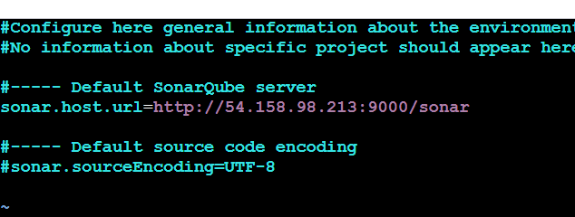

Access SonarQube & Generate Token
Open browser → Go to http://<Your-EC2-Public-IP>:9002 → Login with admin / admin → Set new password → Click profile (top-right) → My Account > Security → Create token named jenkins-token → Click Generate → Copy the token for Jenkins.

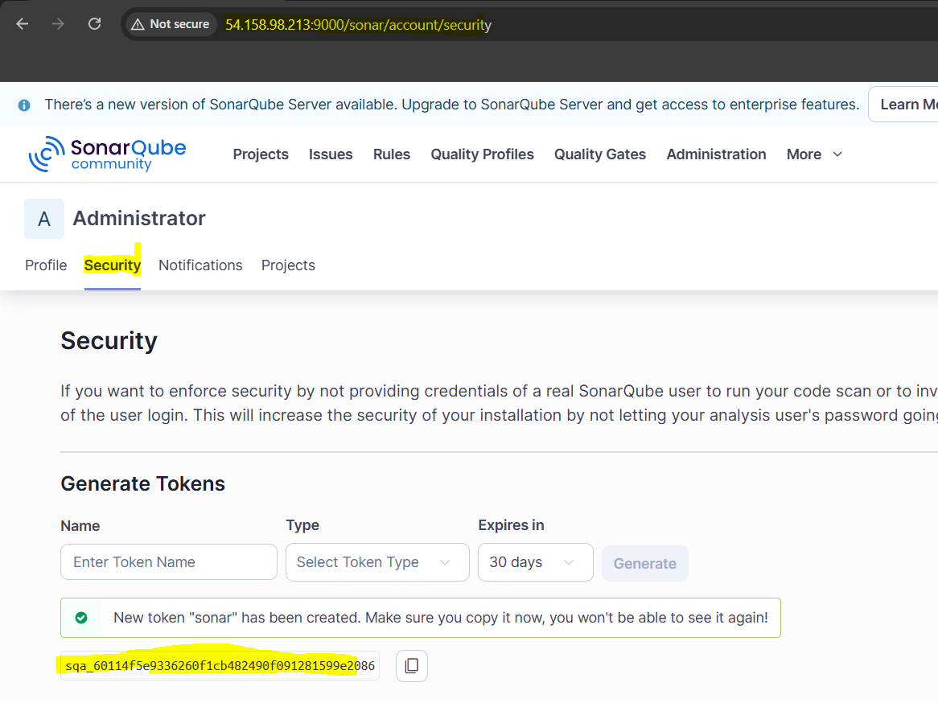
sqa_60114f5e9336260f1cb482490f091281599e2086

Configure SonarQube in Jenkins
Go to Jenkins Dashboard → Manage Jenkins → Manage Plugins → Search and install "SonarQube Scanner" plugin (install without restart)
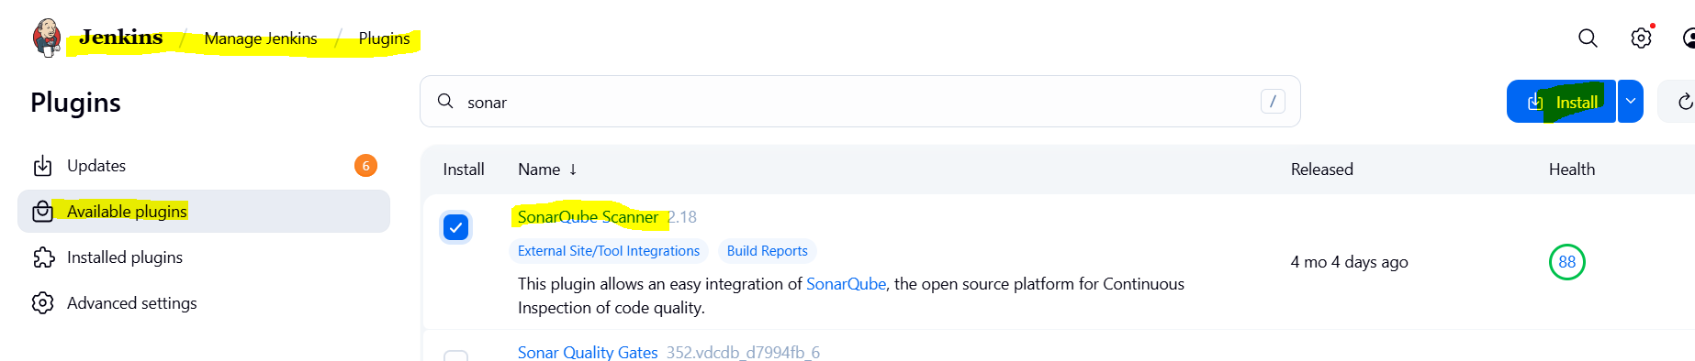
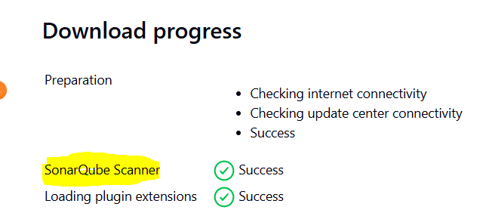

After plugin is installed → Go to Manage Jenkins → Configure System
→ Scroll to SonarQube Servers → Click Add SonarQube
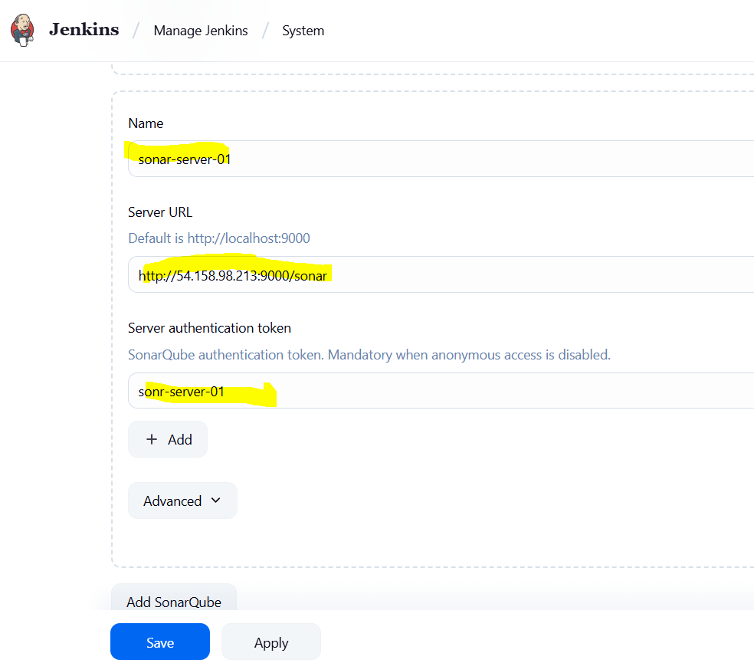
Name: Sonar-Server-01
Server URL: http://<Your-EC2-IP>:9000
Server Authentication Token:
→ Click Add → Jenkins → Kind: Secret Text
→ Paste the token copied from SonarQube
→ ID: sonar-token (or any name)
→ Click Add
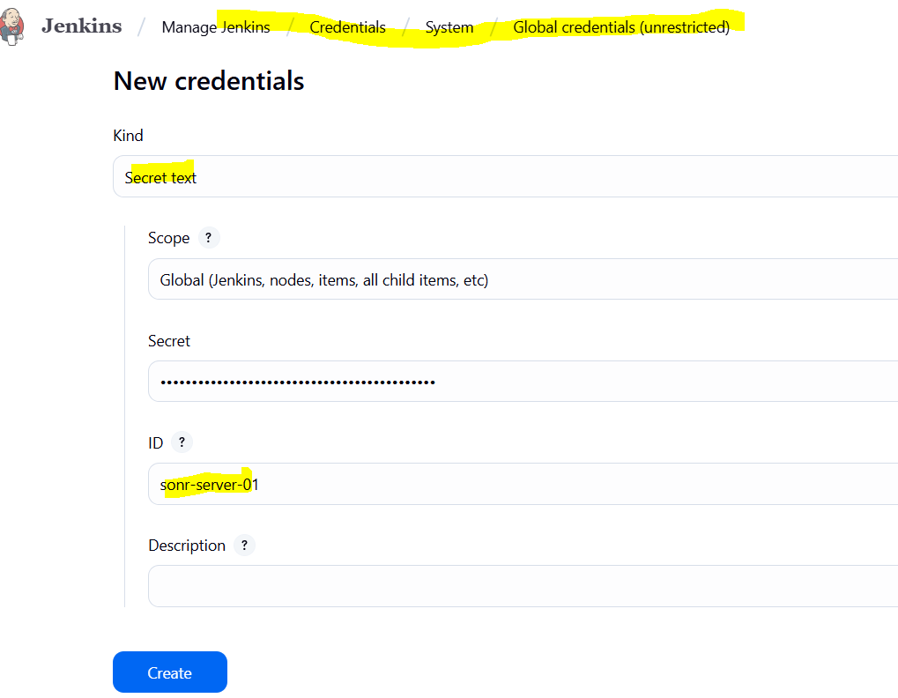
Check "Server authentication token" is selected → Click Save

Add SonarQube Analysis to Existing Git Clone Job
Open your existing Jenkins job (VProfile-01) → Click Configure
→ Scroll down to Build section → Click Add build step → Select Execute SonarQube Scanner
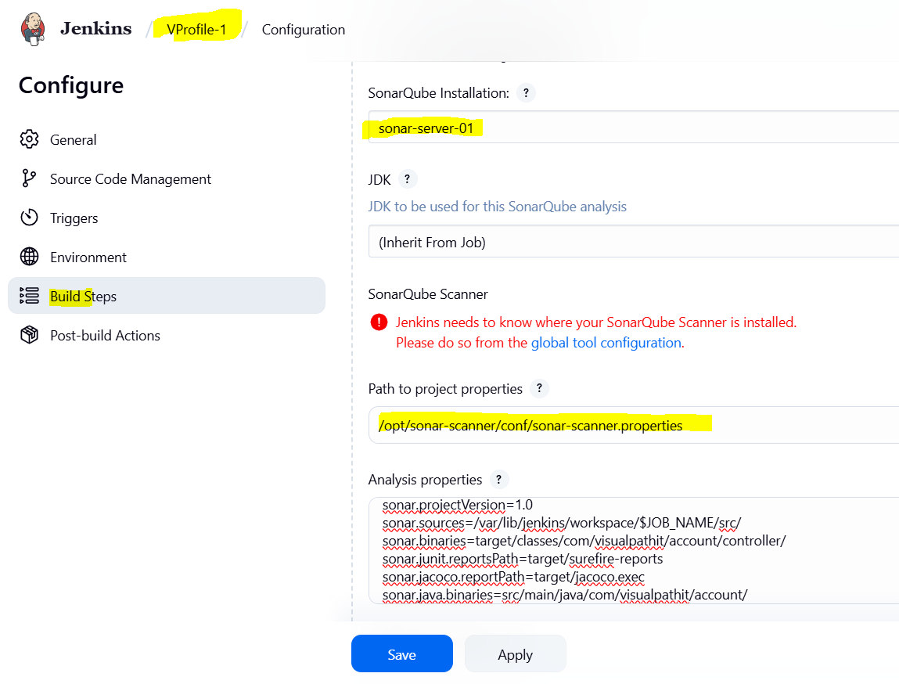

In the "Analysis properties" field, paste this (or load from your Git repo if sonar-project.properties file already exists):
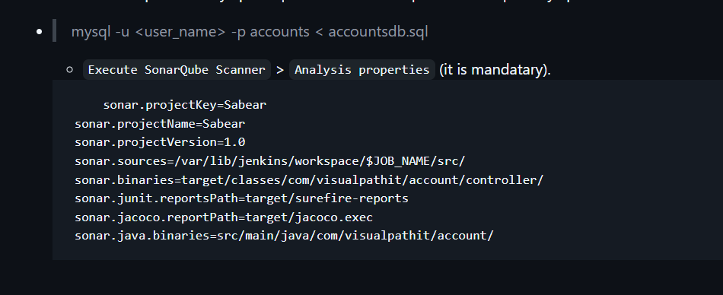

Click Save → Click Build Now → Go to Console Output and check for successful SonarQube analysis.
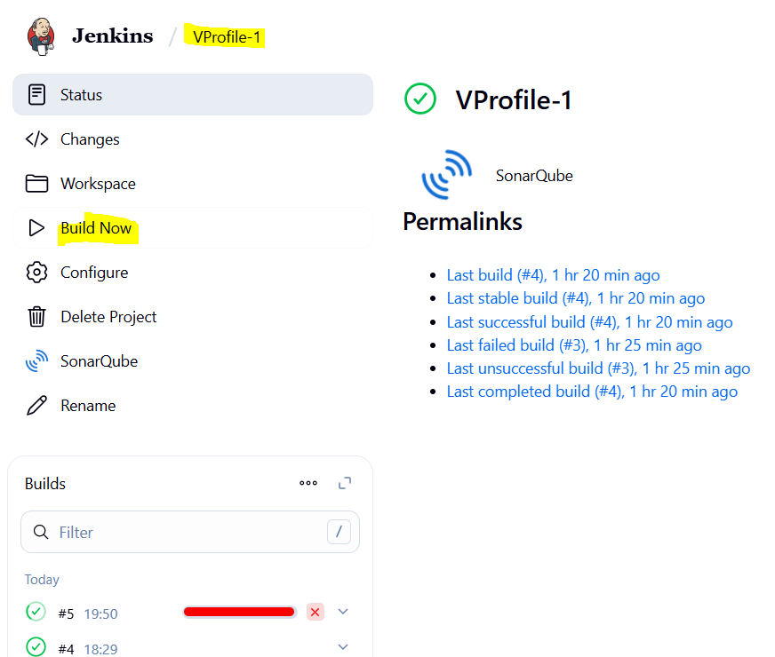
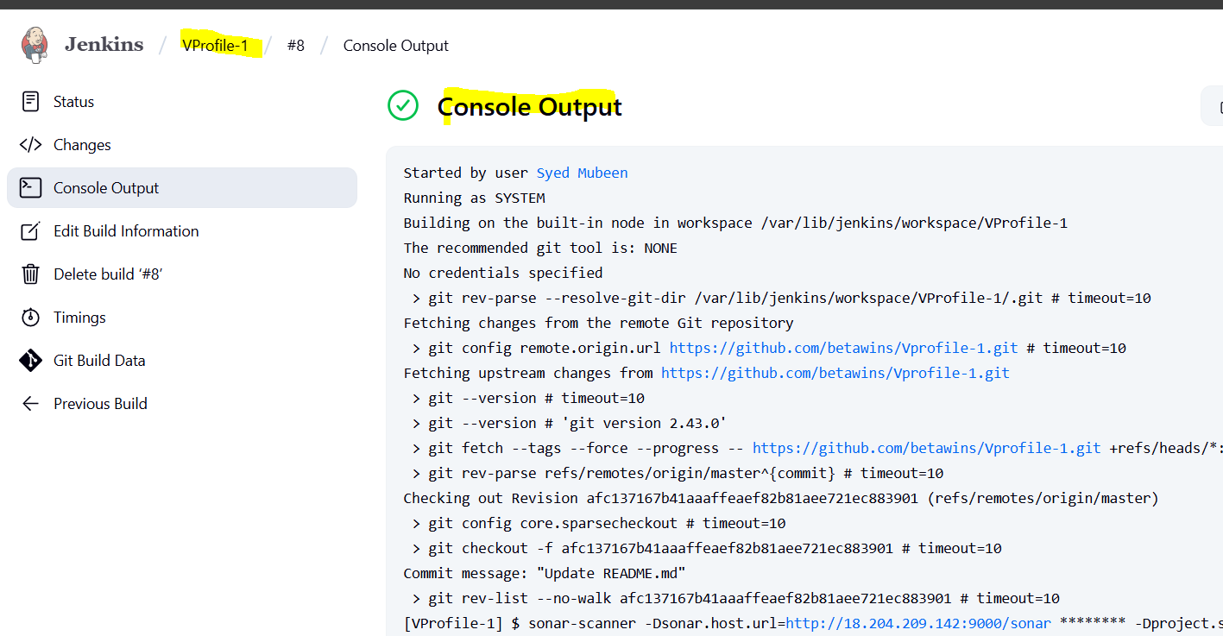
Open browser → Go to http://<Your-EC2-IP>:9000 → Verify the project hiring-app is listed and analysed.
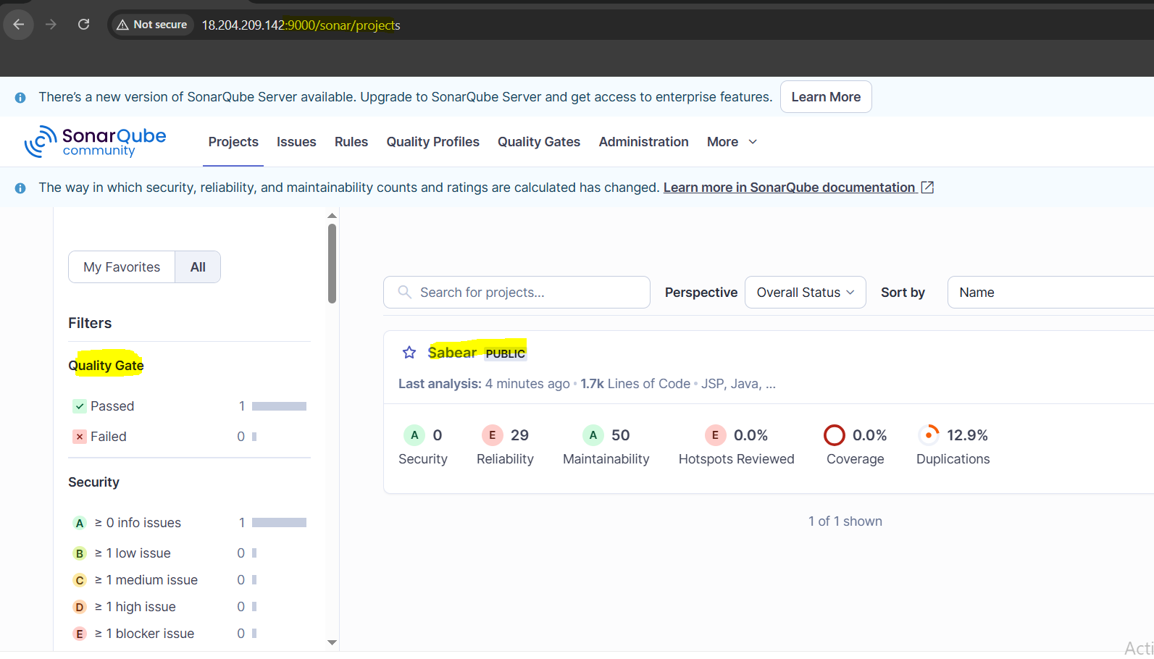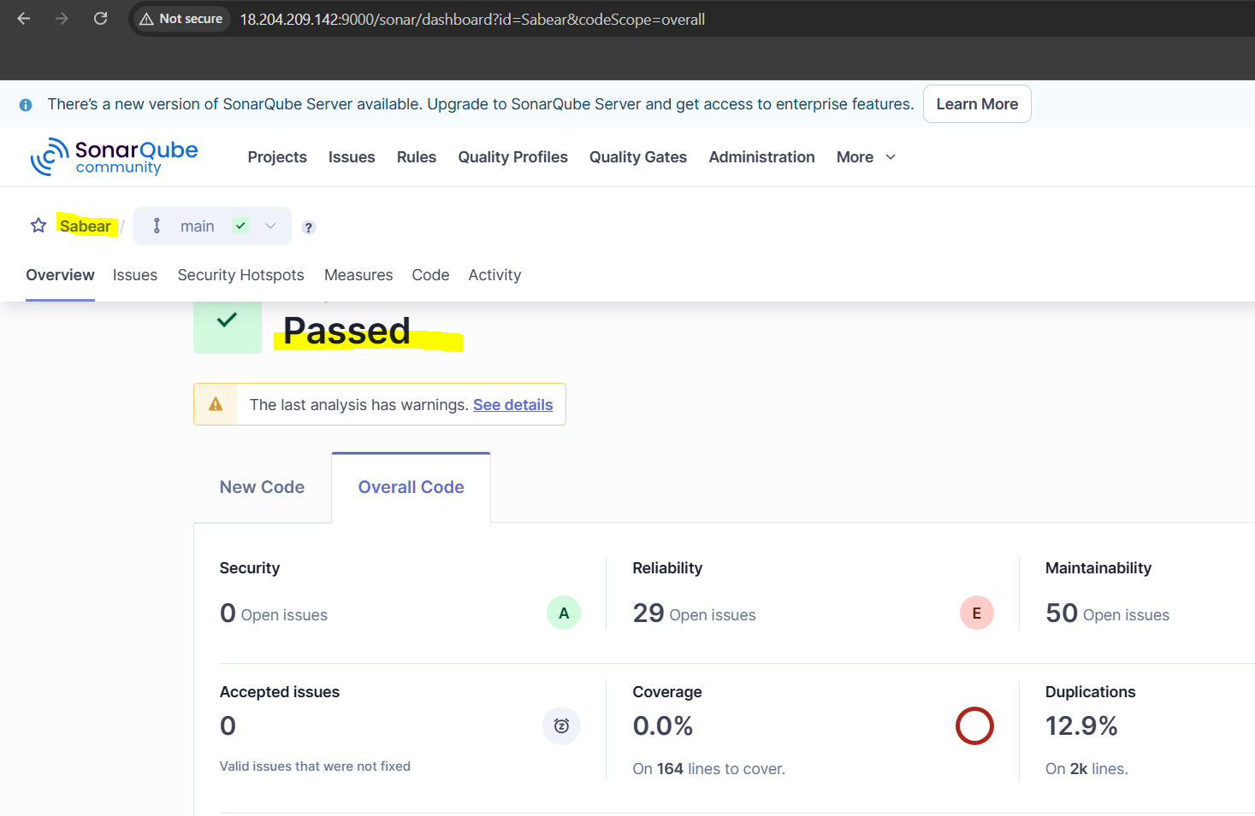

Stage3: Slack Integration to send the alerts to slack.
Go to Jenkins Dashboard → Manage Jenkins → Manage Plugins
→ Search and install “Slack Notification” plugin → Restart Jenkins if needed.
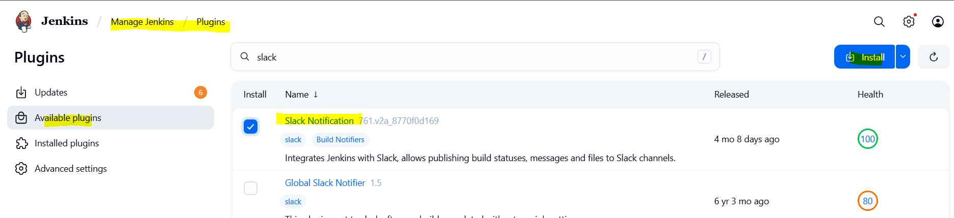
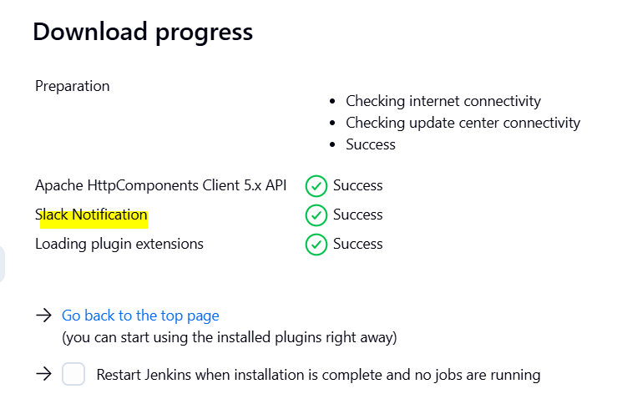

In Slack, create a new Incoming Webhook in your workspace:
→ Go to Slack App Directory → Search Incoming Webhooks → Add to your workspace
→ Choose the channel to send alerts → Copy the Webhook URL
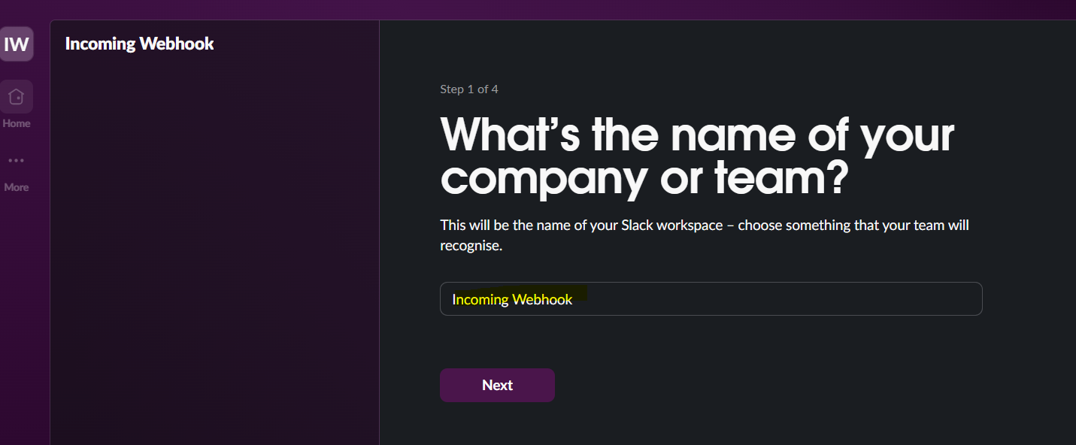
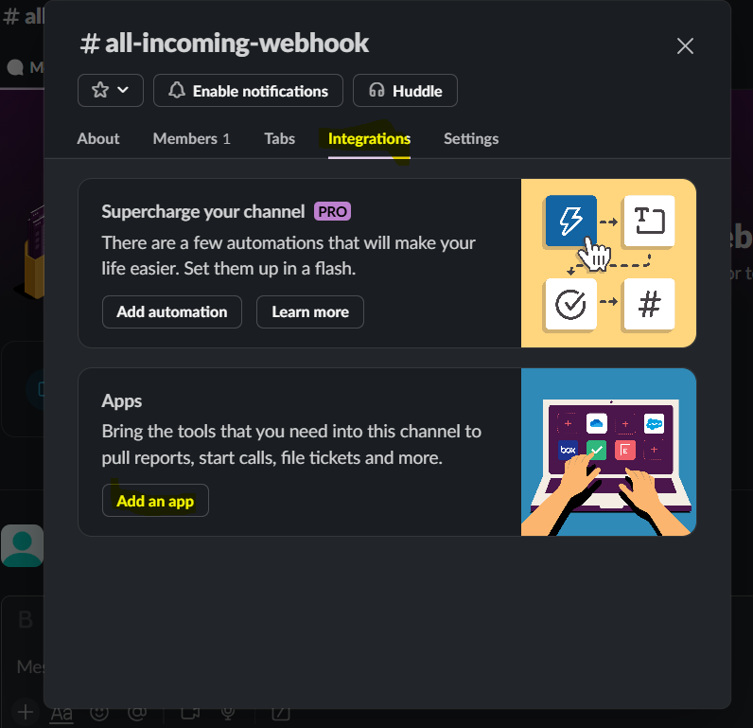
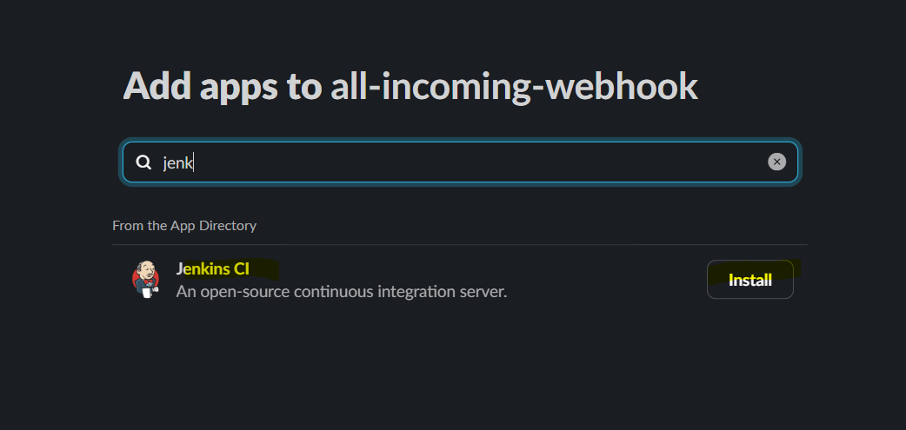
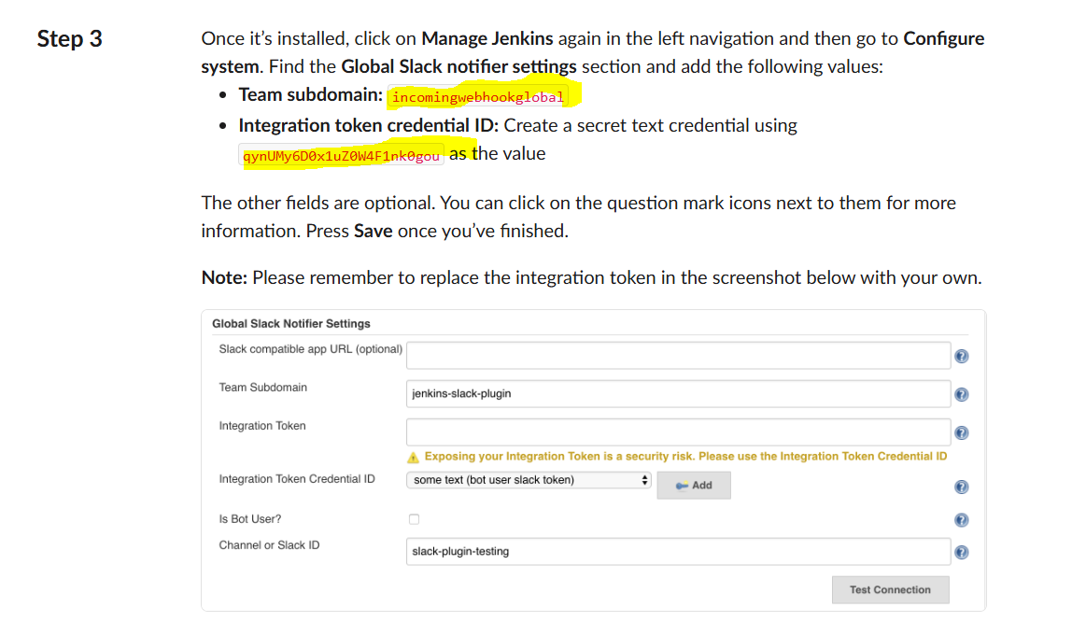
Go back to Jenkins → Manage Jenkins → Configure System
→ Scroll to Slack section → Fill in:
- Workspace (your Slack workspace domain)
- Default Channel (e.g., #jenkins-alerts)
- Integration Token Credential → Click Add → Select Secret text → Paste the Webhook URL → Save credential
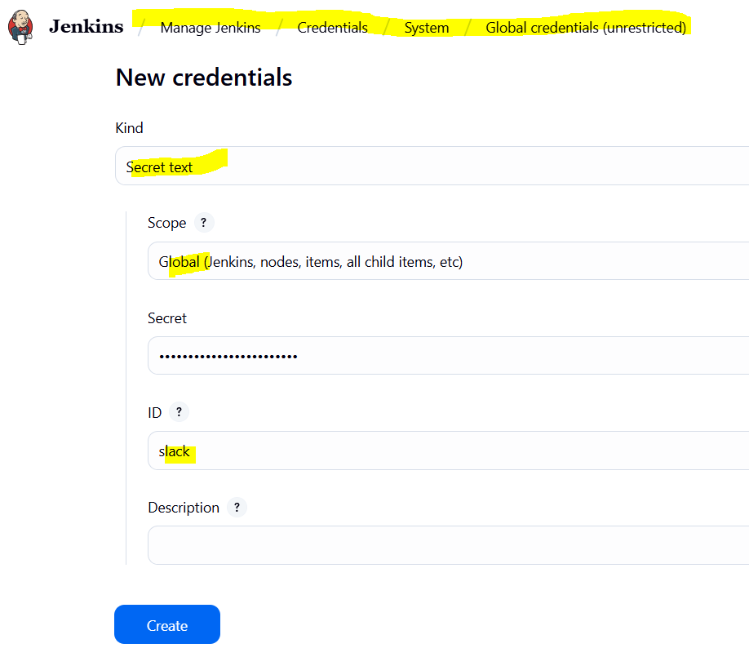
- Select the newly added credential
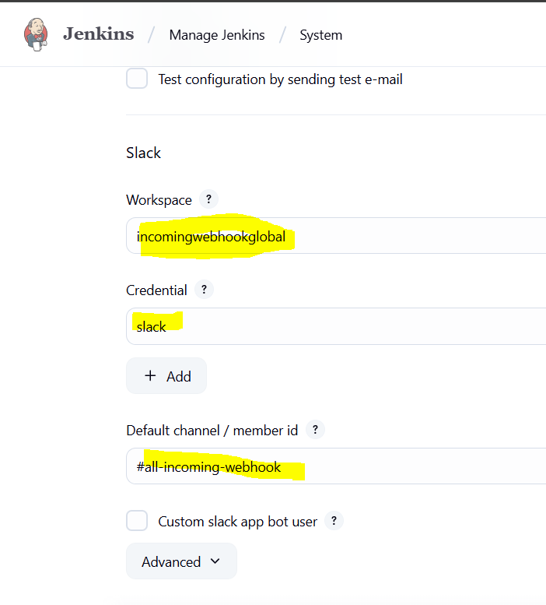

Open your Jenkins job → Click Configure
→ Scroll down to Post-build Actions
→ Click Add post-build action → Select Slack Notifications
→ Check Notify Success, Notify Failure, etc. as needed
→ Save the job
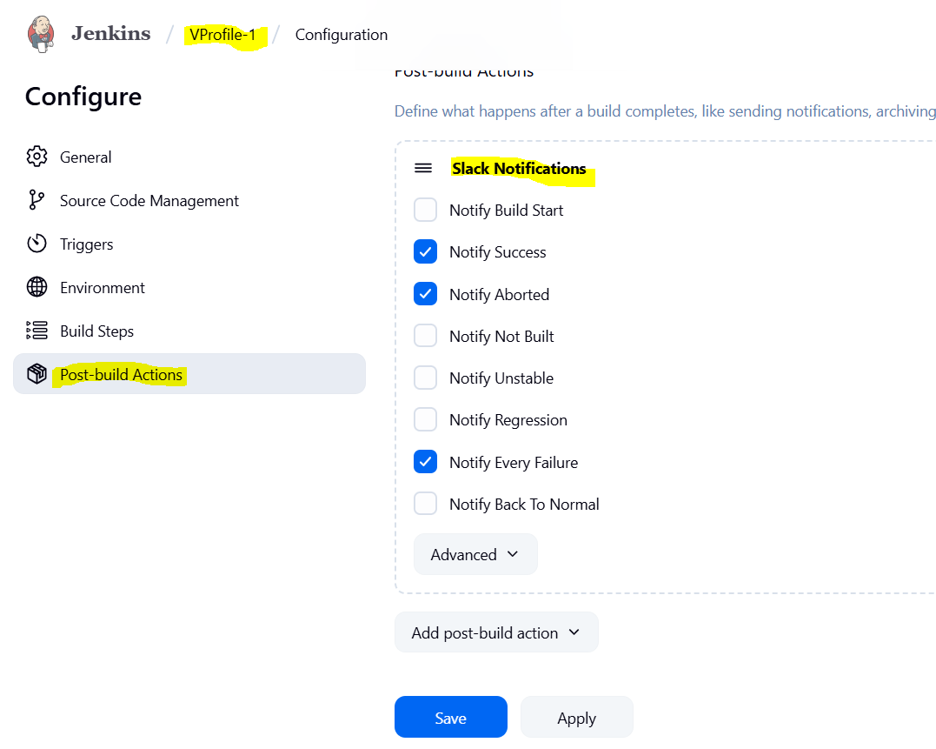
Trigger a build → Confirm Slack channel receives notifications.
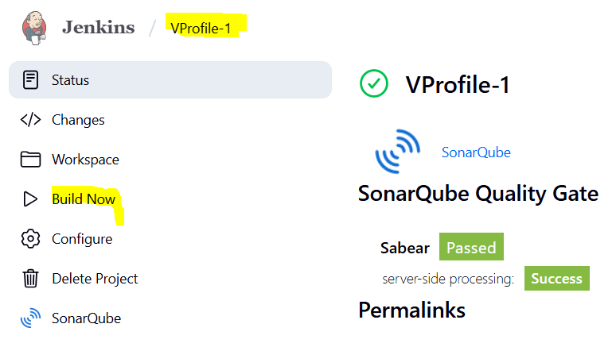
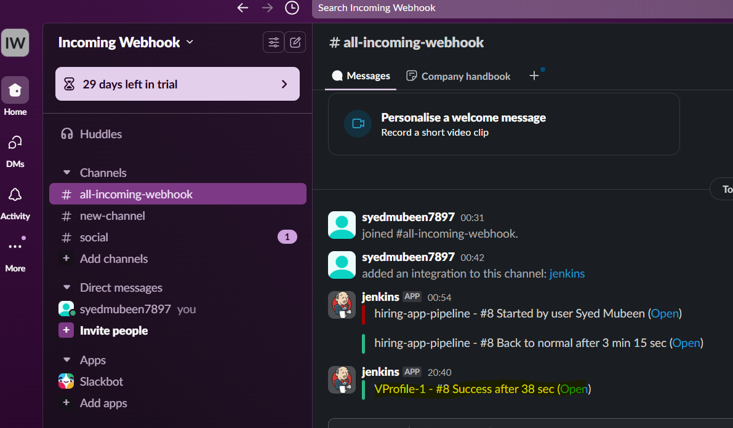

2) Create one jenkins job using the below code and create three stages. stage1: Git clone to download the source code. stage2: Sonarqube Integration to check the quality of code stage3: Slack Integration to send the alerts to slack. URL: https://github.com/betawins/hiring-app.git

Stage1: Git clone to download the source code.
Click New Item
→ Enter a name: hiring-app-pipeline
→ Select Freestyle project
→ Click OK
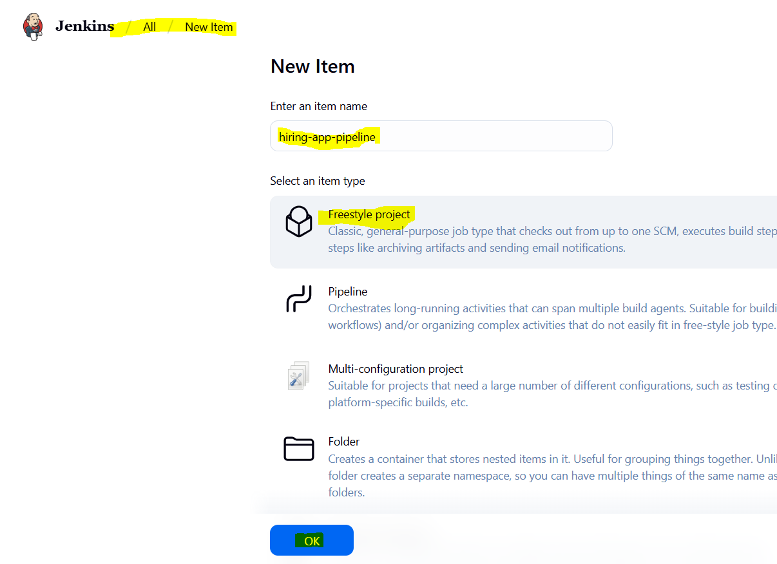

Scroll to Source Code Management
→ Select Git
→ In Repository URL, paste:
https://github.com/betawins/hiring-app.git
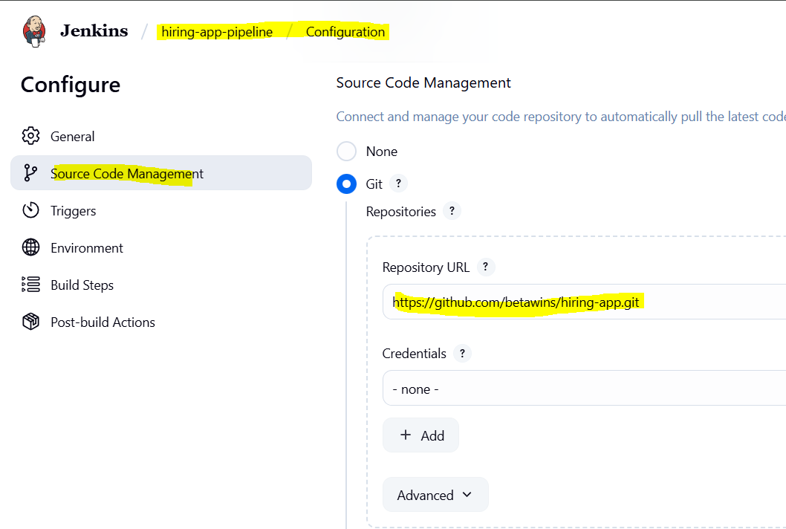
Click Save
→ Click Build Now
→ Click on the latest build → Console Output
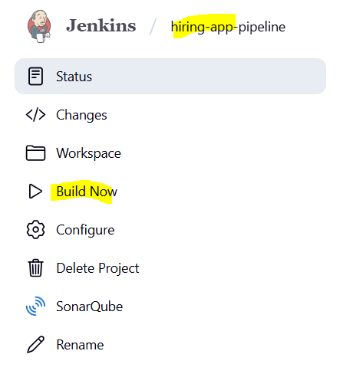

Verify in server at var/lib/Jenkins/workspace path.
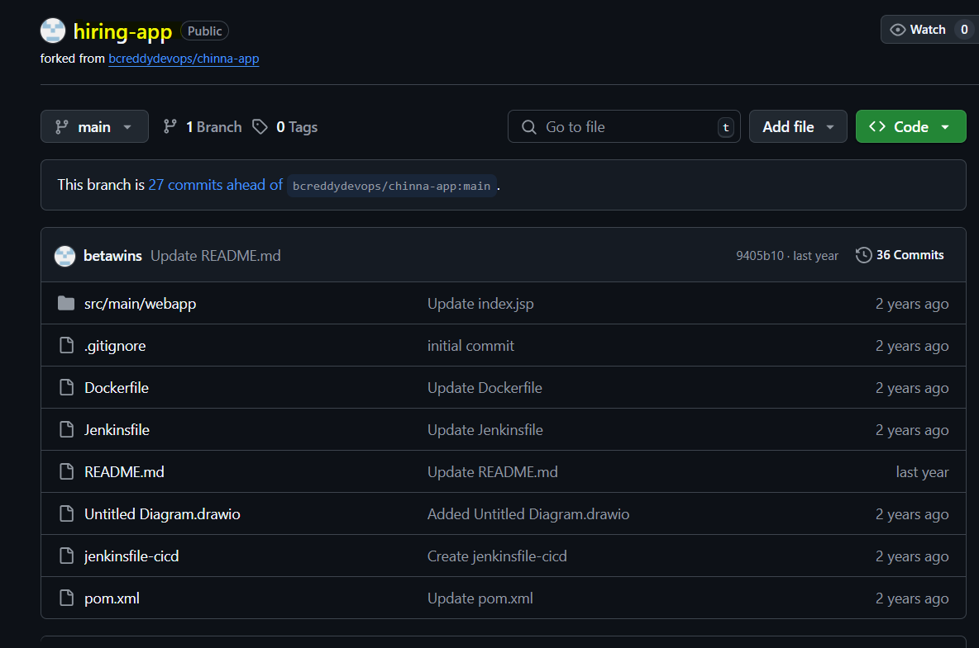

Stage2: Sonarqube Integration to check the quality of code

SonarQube set-up with Docker Container.
Switch to root user
sudo su -
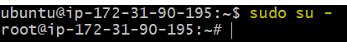

Update package lists
apt update
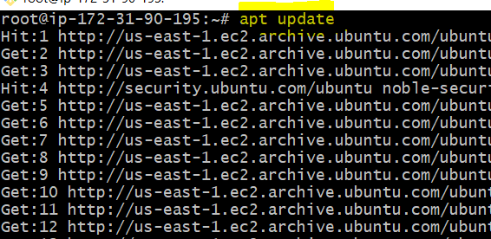

Install Docker (correct package name is docker.io)
apt -y install docker.io
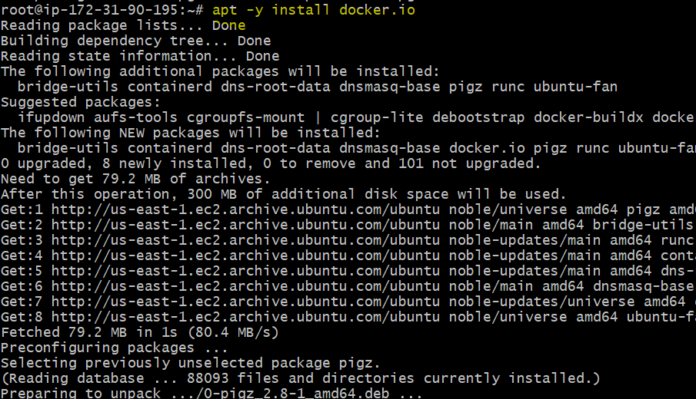

Start and enable Docker service
systemctl start docker
systemctl enable docker
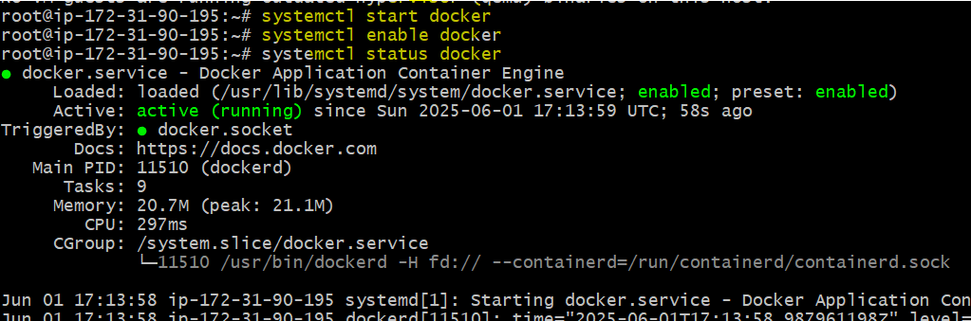

Pull the latest SonarQube image from Docker Hub
docker pull sonarqube
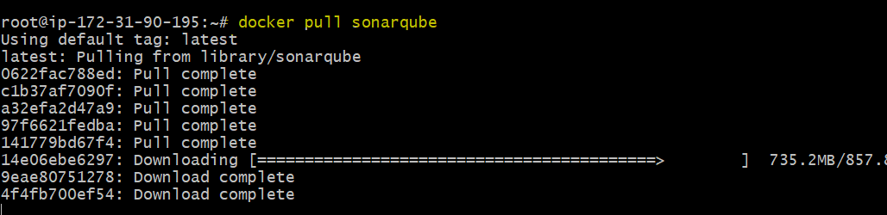

List downloaded Docker images
docker images
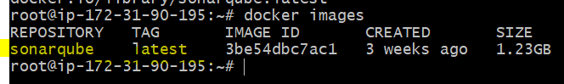

Run SonarQube container in detached mode, mapping host port 9002 to container port 9000
docker run -itd -p 9002:9000 --name sonarqube sonarqube

List Docker images again to confirm it's still available
docker images
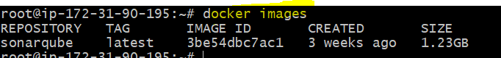

List running Docker containers
docker ps

Verifying on browser
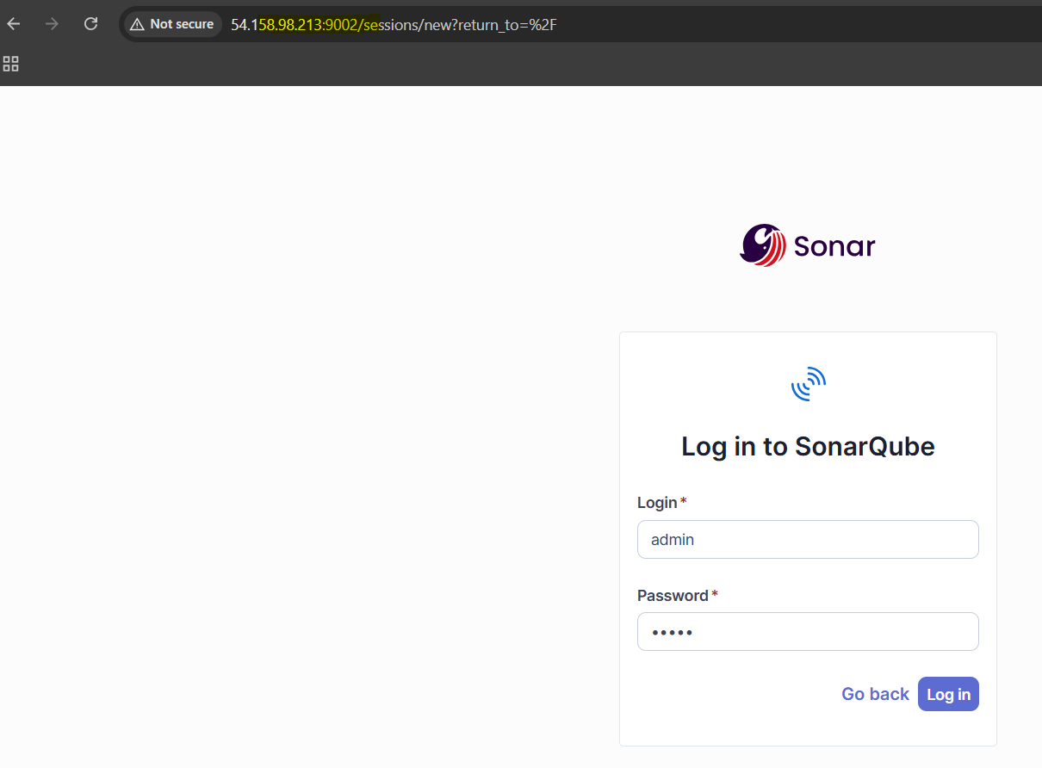

Install Sonar Scanner on Jenkins Server
Switch to root user on Jenkins EC2
sudo su -


Download and install Sonar Scanner
cd /opt
wget https://binaries.sonarsource.com/Distribution/sonar-scanner-cli/sonar-scanner-cli-5.0.1.3006-linux.zip


unzip sonar-scanner-cli-5.0.1.3006-linux.zip


mv sonar-scanner-* sonar-scanner


Configure Sonar Scanner Properties
Edit the Sonar Scanner configuration
vi /opt/sonar-scanner/conf/sonar-scanner.properties
sonar.host.url=http://<Your-EC2-Public-IP>:9002
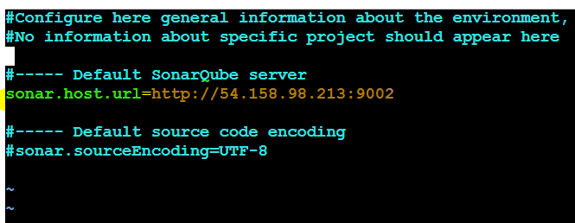

Access SonarQube & Generate Token
Open browser → Go to http://<Your-EC2-Public-IP>:9002 → Login with admin / admin → Set new password → Click profile (top-right) → My Account > Security → Create token named jenkins-token → Click Generate → Copy the token for Jenkins.

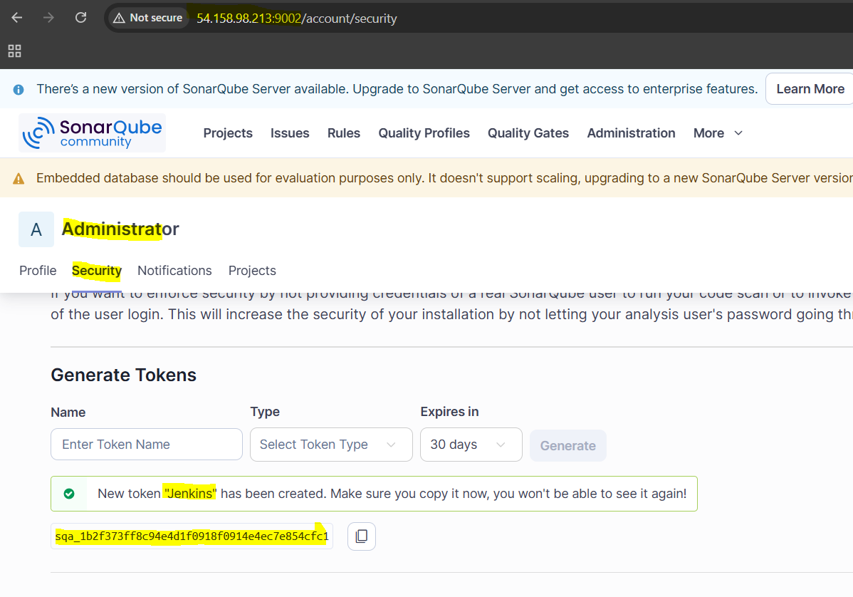

sqa_1b2f373ff8c94e4d1f0918f0914e4ec7e854cfc1

Configure SonarQube in Jenkins
Go to Jenkins Dashboard → Manage Jenkins → Manage Plugins → Search and install "SonarQube Scanner" plugin (install without restart)



After plugin is installed → Go to Manage Jenkins → Configure System
→ Scroll to SonarQube Servers → Click Add SonarQube
Name: Sonar-Server
Server URL: http://<Your-EC2-IP>:9002
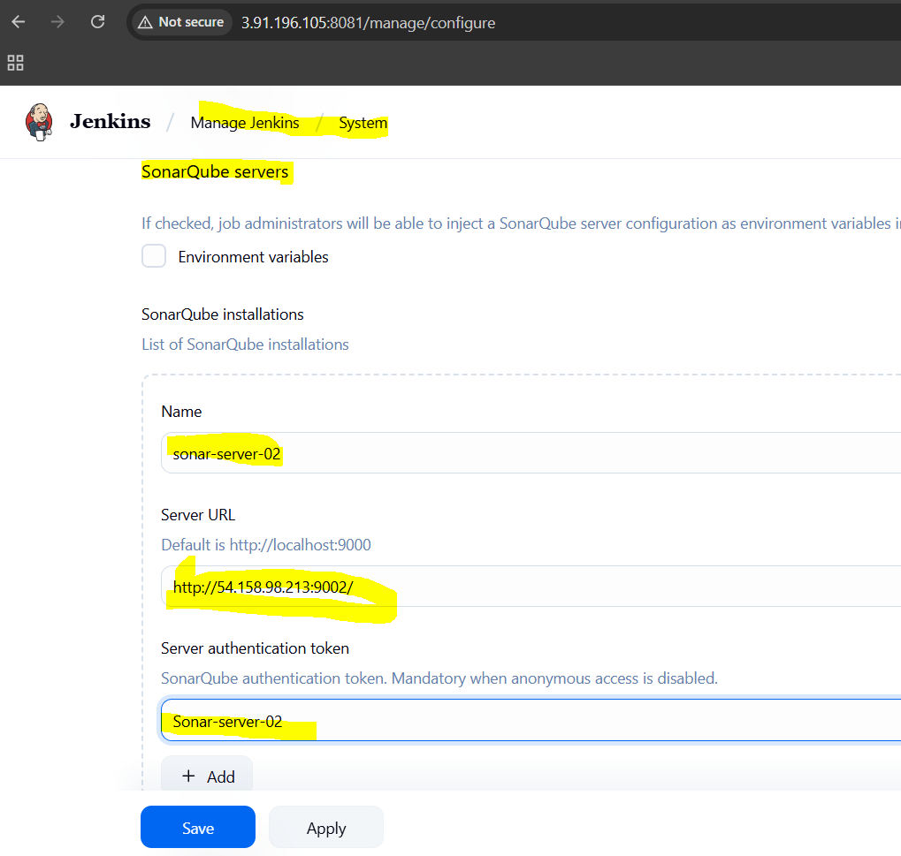

Server Authentication Token:
→ Click Add → Jenkins → Kind: Secret Text
→ Paste the token copied from SonarQube
→ ID: sonar-server-02 (or any name)
→ Click Add
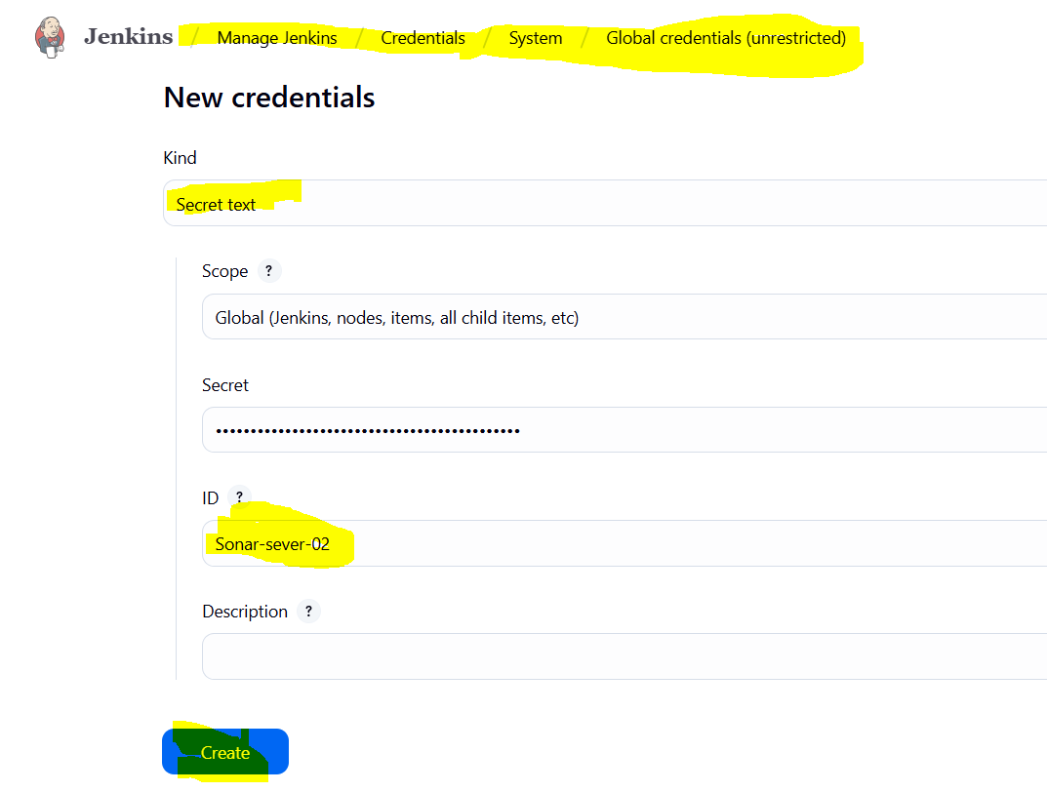

Add SonarQube Analysis to Existing Git Clone Job
Open your existing Jenkins job (hiring-app-pipeline) → Click Configure
→ Scroll down to Build section → Click Add build step → Select Execute SonarQube Scanner
In the "Analysis properties" field, paste this (or load from your Git repo if sonar-project.properties file already exists):
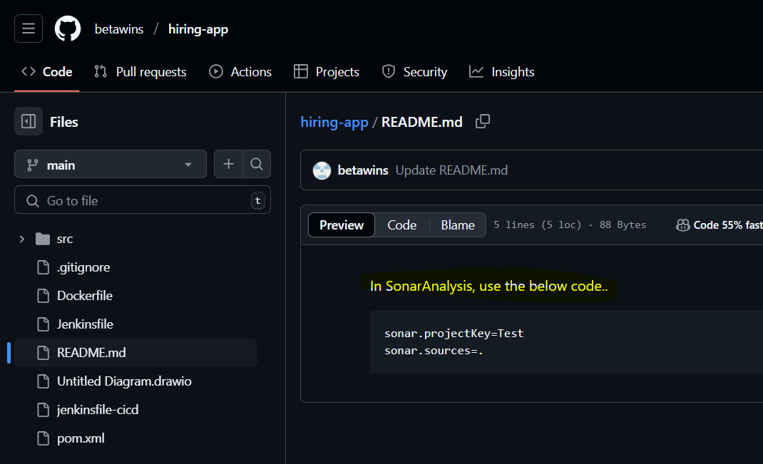
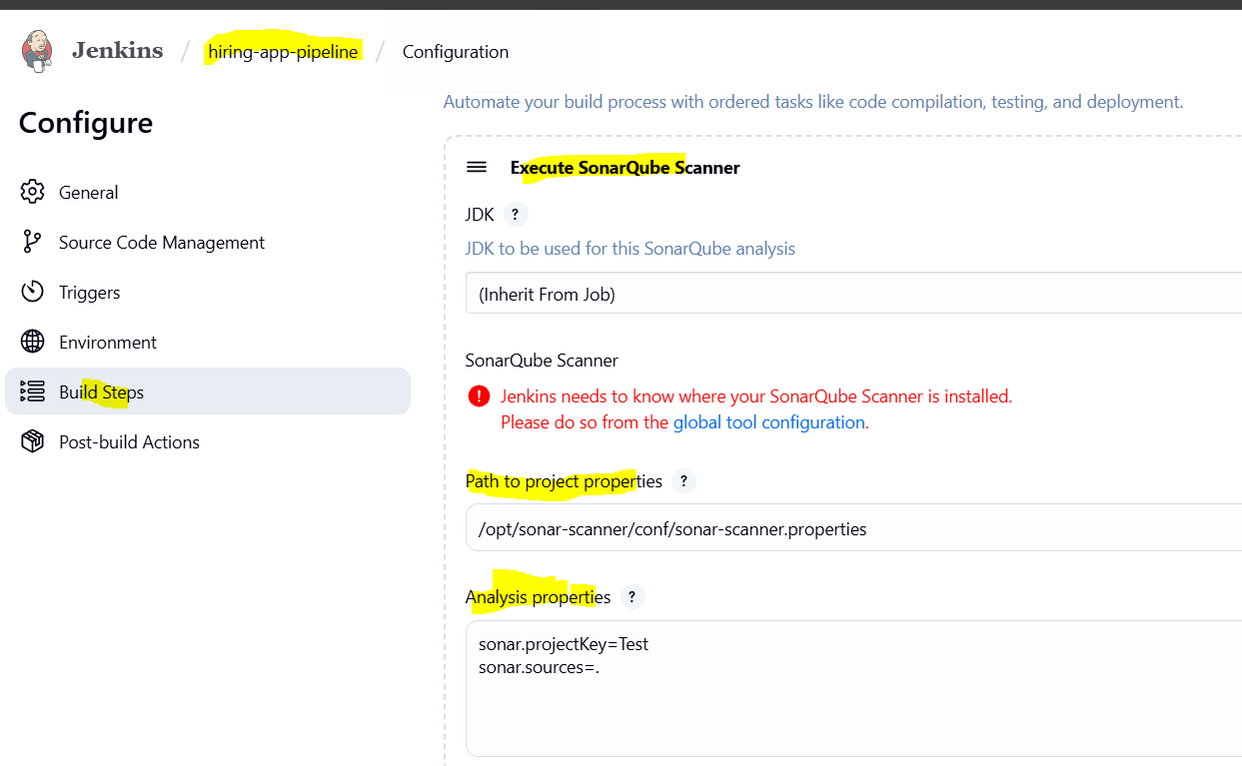

Click Save → Click Build Now → Go to Console Output and check for successful SonarQube analysis.
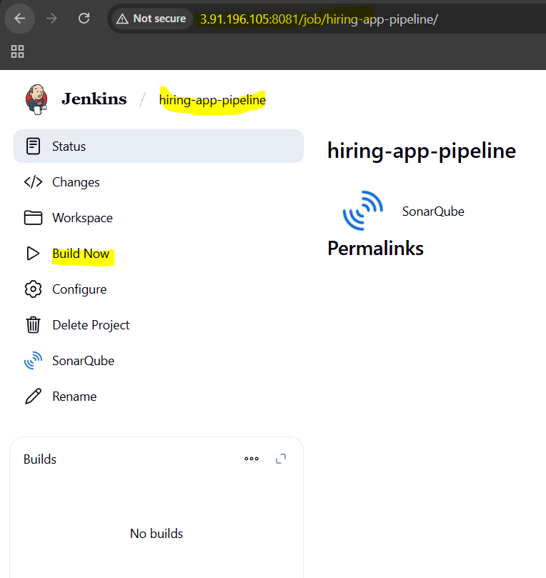
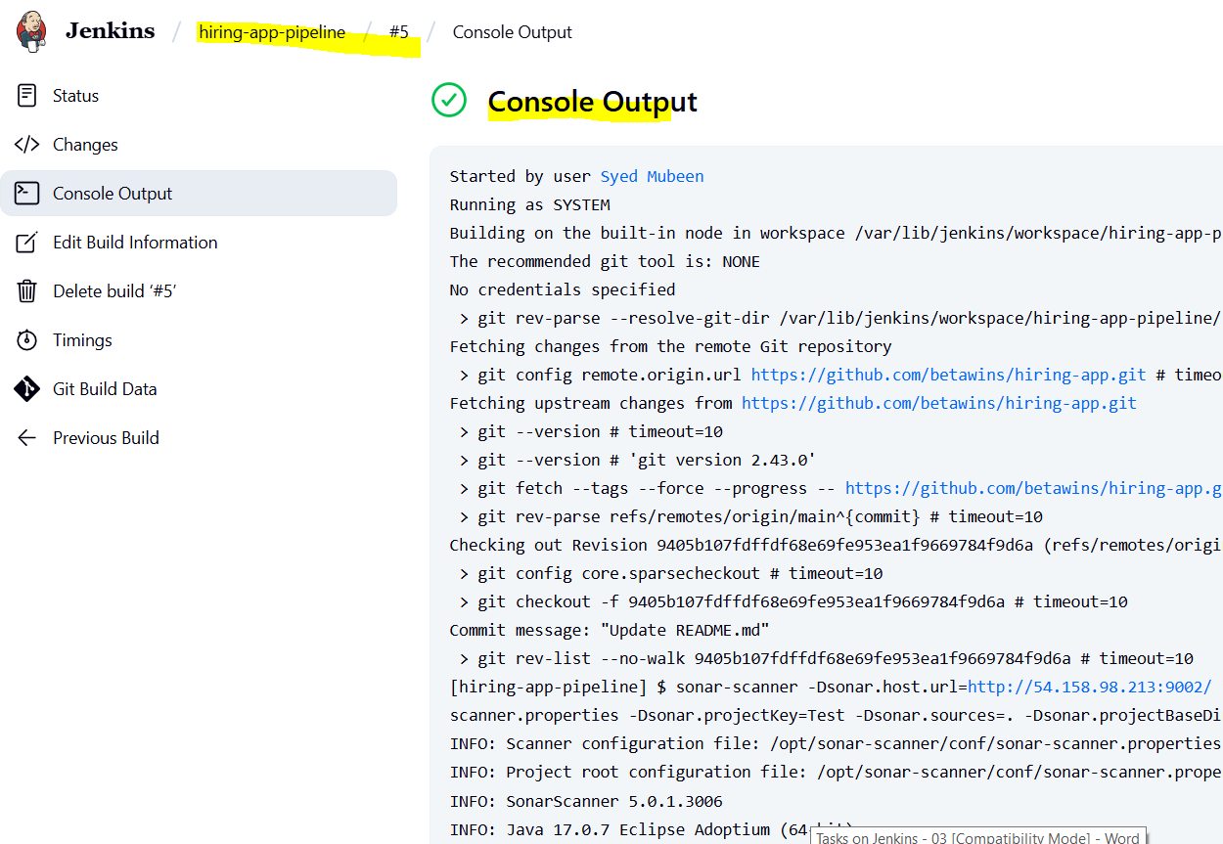

Open browser → Go to http://<Your-EC2-IP>:9002 → Verify the project hiring-app is listed and analysed.
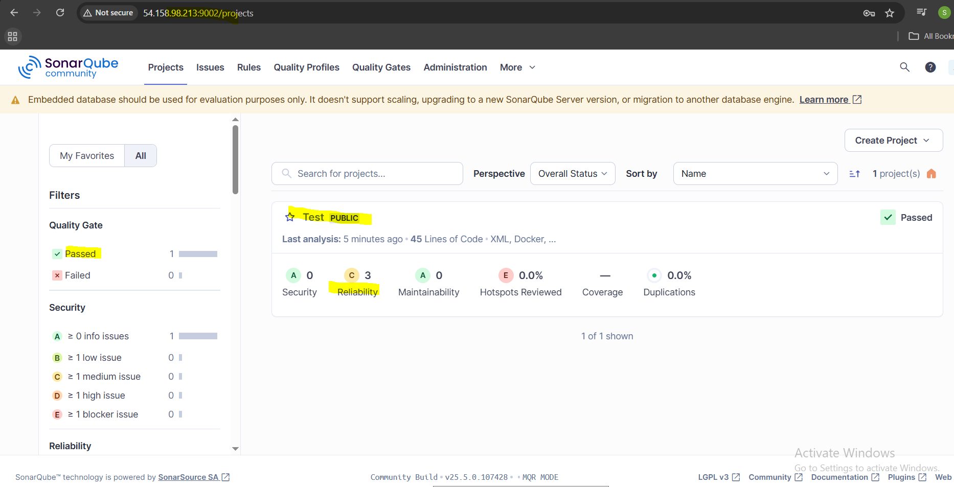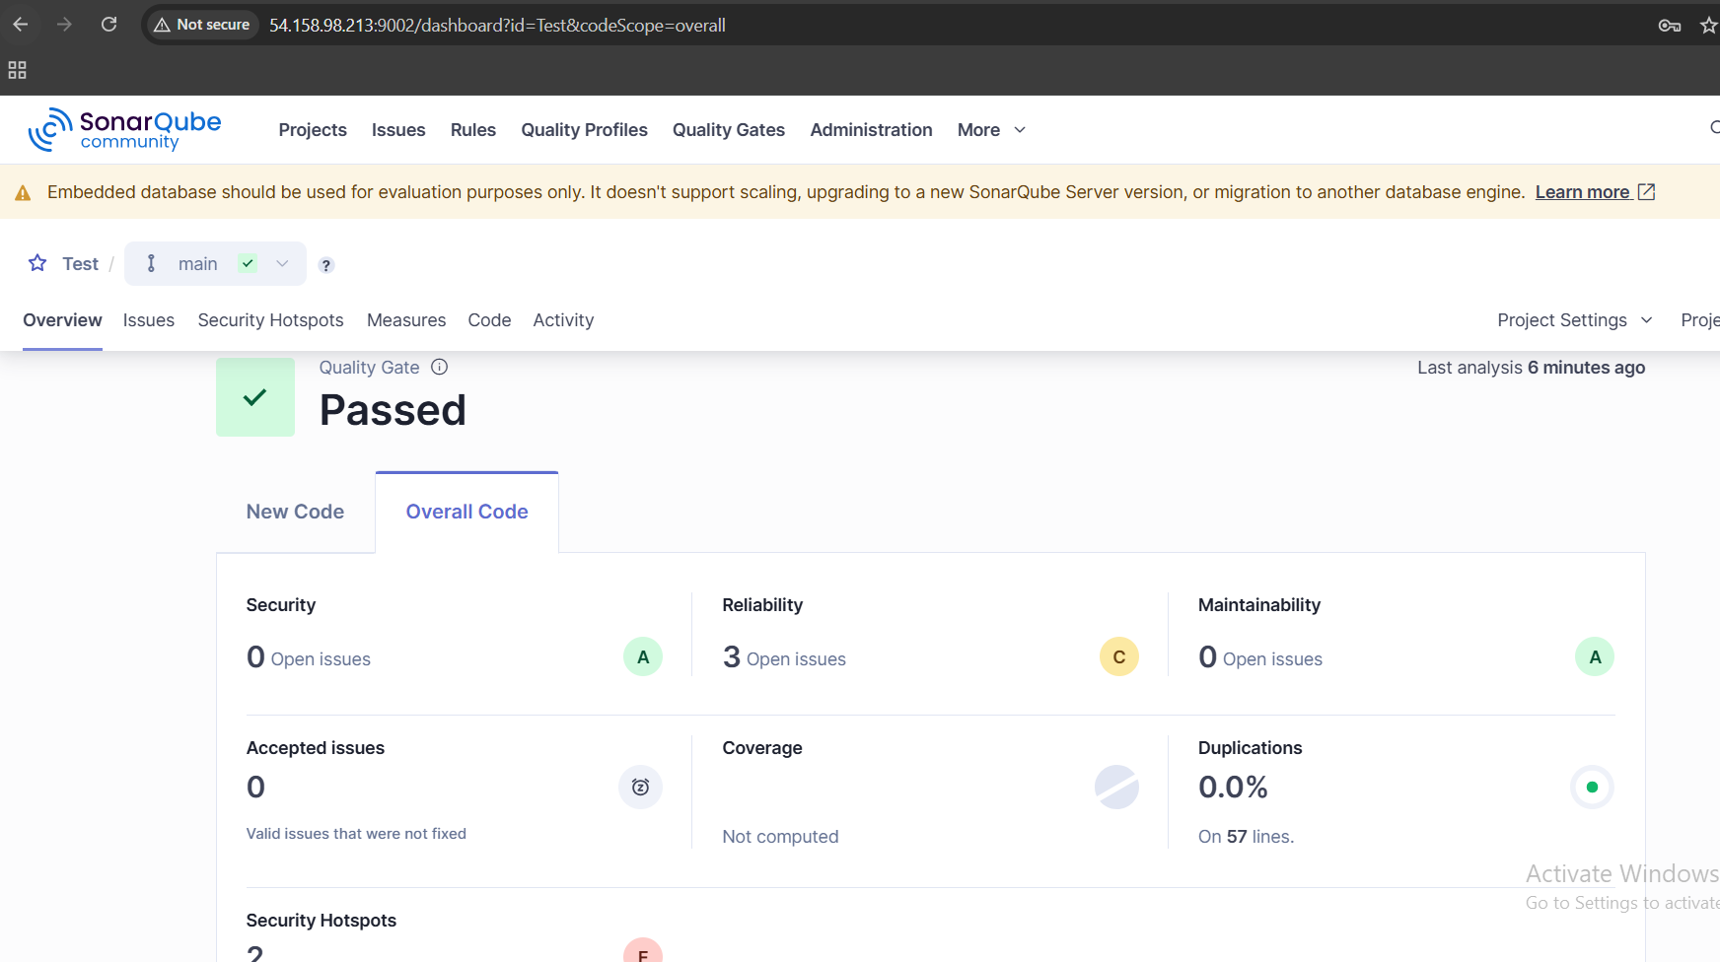

Stage3: Slack Integration to send the alerts to slack.
Go to Jenkins Dashboard → Manage Jenkins → Manage Plugins
→ Search and install “Slack Notification” plugin → Restart Jenkins if needed.



In Slack, create a new Incoming Webhook in your workspace:
→ Go to Slack App Directory → Search Incoming Webhooks → Add to your workspace
→ Choose the channel to send alerts → Copy the Webhook URL




Go back to Jenkins → Manage Jenkins → Configure System
→ Scroll to Slack section → Fill in:
- Workspace (your Slack workspace domain)
- Default Channel (e.g., #jenkins-alerts)
- Integration Token Credential → Click Add → Select Secret text → Paste the Webhook URL → Save credential

- Select the newly added credential


Open your Jenkins job → Click Configure
→ Scroll down to Post-build Actions
→ Click Add post-build action → Select Slack Notifications
→ Check Notify Success, Notify Failure, etc. as needed
→ Save the job
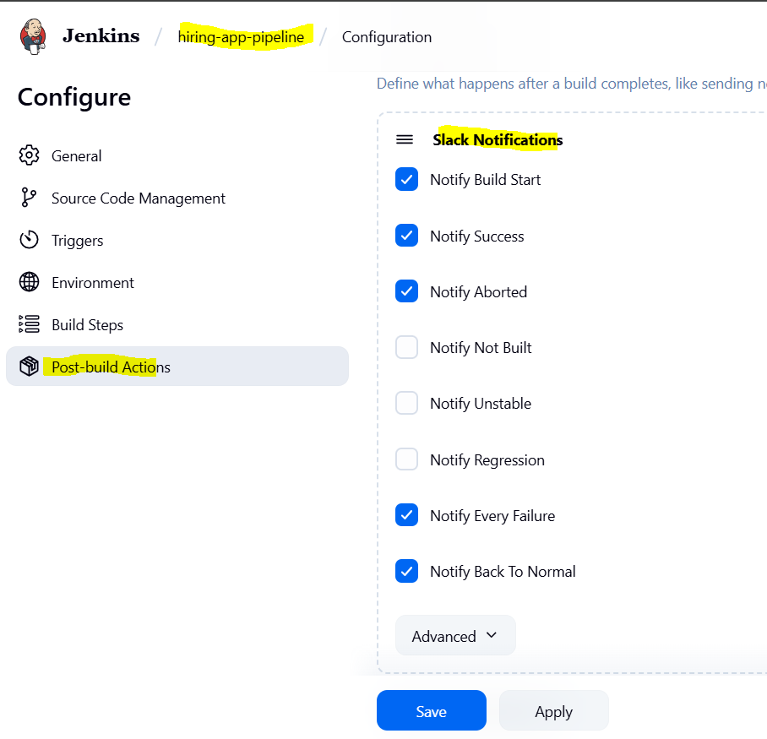
Trigger a build → Confirm Slack channel receives notifications.
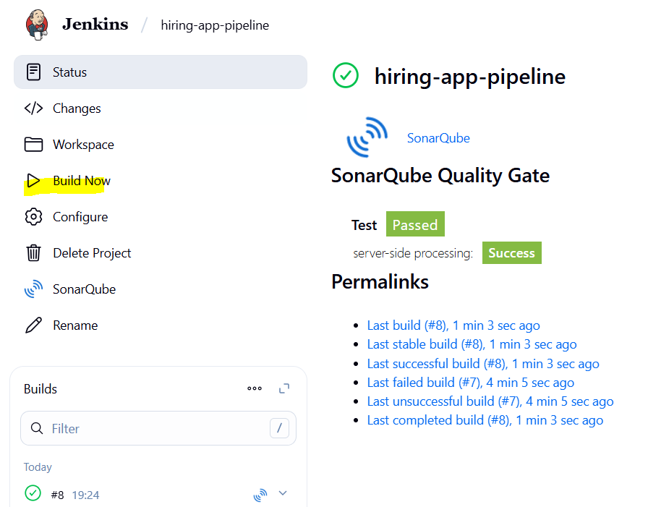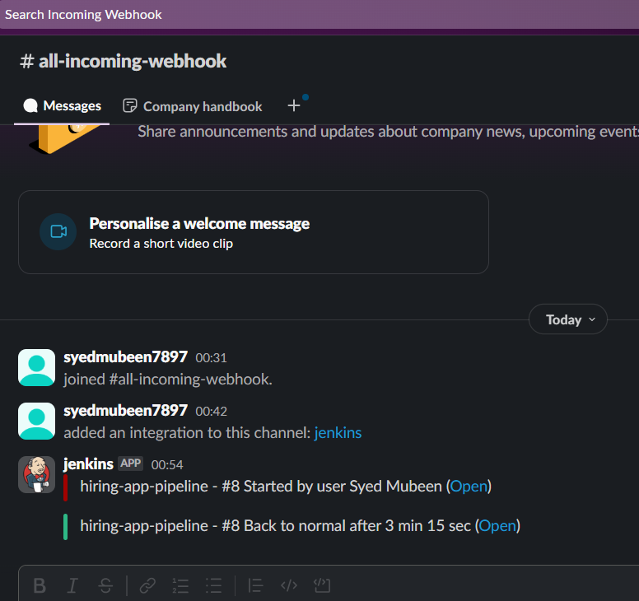

The-End

